DALWALLINU
DISTRICT HIGH SCHOOL

Kindergarten Parent Handbook

Kindergarten 2023

WELCOME to Dalwallinu District High School and in particular the Dalwallinu Kindergarten Centre!
We hope the kindergarten year will be a happy, enjoyable and rewarding experience for you and your child.
The Kindergarten children will be attending in the Early Childhood building at Dalwallinu District High School. Kindergarten is your child’s first year at school. It is a year when school routines are established and your child explores, plays and makes friends.
The program we provide builds on your child’s experiences at home. The Teaching staff will provide experiences for your child to learn social and academic skills through play and active involvement with other children and adults.
Participation in early childhood education programs equips your child with essential skills that prepare them for future schooling as well as providing the foundations they will need to cope with the demands of a continuously changing world. Early childhood programs emphasise social and emotional development, early literacy and numeracy, and physical development.
At our centre we aim to structure the learning environment to incorporate play while implementing the Early Years Learning Framework and the Australian Curriculum.
We look forward to working alongside you and your child during their first year of schooling at Dalwallinu DHS.

Sarah Johnson
Kindergarten Teacher
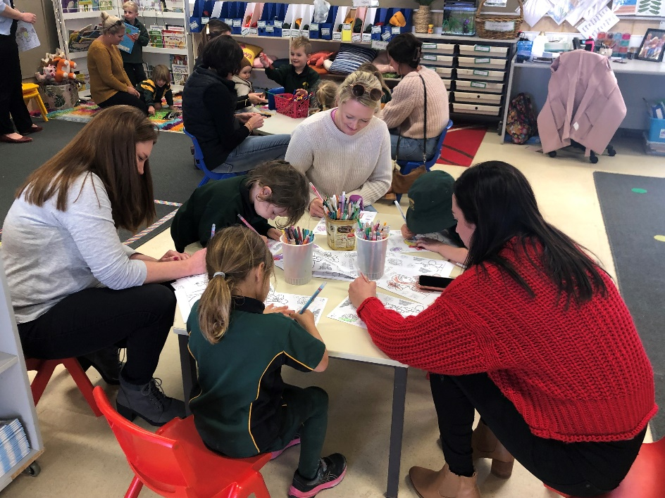

SCHOOL CONTACT DETAILS
For all enquiries, please first contact the School Reception. Reception at the School is open between the hours of 8:00am and 4.00pm, Monday to Friday during school terms.

T: 08 6661 1500
E: Dalwallinu.dhs@education.wa.edu.au

Administration Staff:
Principal: Petrina Bean

Deputy Principals: Melissa Harms - Primary
William Stewart - Secondary

Manager Corporate Services: Jenny Sawyer

School Officer: Rachael Lehmann

TIMES AND DATES

SCHOOL HOURS
School Commences: 8:50am
Morning Recess: 11:00am – 11:20am
Lunch: 1:00pm - 1:35pm
School Dismissed: 3:00pm (2.35pm on Wednesdays)

TERM DATES FOR 2023 (for students)
Semester 1 Term 1 Wednesday 1st February – Thursday 6th April
Term 2 Wednesday 26th April – Friday 30th June

Semester 2 Term 3 Monday 17th July – Friday 22nd September
Term 4 Monday 9th October – Thursday 14th December

OFFICE and SCHOOL DEVELOPMENT DAYS 2023 (students do not attend on these days)
Term 1 – Monday 30th January and Tuesday 31st
Term 2 - Monday 24th April, Friday 2nd June
Term 3 - Wednesday 30th August

PUBLIC HOLIDAYS FOR 2023
Labour Day Monday 6th March
Good Friday Friday 7th April
ANZAC Day Tuesday 25th April
WA Day Monday 5th June

List of Requirements

(Names to be clearly marked on all items)

- 1 LARGE Backpack (to accommodate items such as spare clothes, lunch box, drink bottle and artwork, which your child can open and close INDEPENDENT OF AN ADULT).
- 1 Faction Hat to be left at Kindy. All children are expected to wear a hat when playing outside all year round (purchased through the canteen).
- 1 Water Bottle – send full each day.
- 1 SMALL Cushion for rest time. (No bigger than 25cm)
- 1 LARGE Library Bag
- Crunch and Sip, Morning Tea and Lunch to be brought in SEPARATE named containers.
- Spare clothes - Children are required to bring to each Kindy day a change of uniforms, including underwear (in case of an accident). Please update to changes of season and your child’s growth.

What to do on the first day of Kindergarten

On your child’s first Kindy morning please help them to unpack their bags. Lunch, Morning tea, Crunch and Sip and water bottles will go into labelled baskets. Library bags, tissues, hats and cushions will be collected by either myself or the Education Assistant. Once your child’s bag is unpacked help them to place their bag on the racks outside the classroom.
The students then sign their names in on the name cards.
Next find a puzzle or activity to complete with your child on the mat until you are comfortable to leave. A bell will ring when I feel most children are ready for the parents to leave.
You may find it helpful to talk with your child about this before they arrive, so that they know what will be happening. Most children are happy to know that when the bell rings, the parents leave and will be back at the end of the day.

Things you can do to help your child to prepare for Kindergarten and to enjoy it once they’ve started.

Helping your child have a positive first experience at school is important,

*Talk about Kindy as fun, something to look forward to.
*Provide materials at home - pencils, crayons, paper, colouring in books, scissors, glue sticks, so your child can draw, write, cut, glue, etc.
*Make a batch of playdough to use.
*Teach your child to recognise their own name.
*Read to them every day.
*Identify colours and shapes in their world.
*Count to 10 and beyond!
*Complete jigsaw puzzles together.
*Talk often – sing nursery rhymes and songs together.
*Join the town library.
* Cook with your child.
*Allow your child to become independent – go to the toilet and dress themselves and wash hands.

Crunch and Sip

The school operates a crunch and sip program whereby students bring in a piece of fruit or cut up vegetables for them to eat. This program promotes healthy eating and provides the students with some brain food to enhance their learning during language activities. The students are to bring in crunch and sip, each day that they are in attendance at Kindergarten.

Read to your child as often as possible.

Reading is an essential skill that all children will develop with varying degrees of success. It is well known by most, that those children who are read to at home have a substantial advantage over those who are not.
Important things you can do at home to help your child are, to provide both support and positive experiences with reading. In addition to this:
*Read stories and ask questions.
*Encourage your child to retell stories using their own words.
*Make up stories using the pictures in books.

General Information

Absentee Notes
Although Kindy is not compulsory, once students are enrolled, attendance is compulsory. Kindergarten is a good time to instil good attendance behaviours. Parents must undertake to send their child to school regularly and if absent provide a reasonable explanation for their child’s absence. If your child is absent from school without reasonable cause then a SMS will be sent from administration to your phone.

Arrival
Kindy children start school at 8.50am each morning. With the exception of bus children, please ensure that children DO NOT ARRIVE UNTIL 8:30AM. It is important that children are not left at school without an adult present. Please ensure that there is a teacher present when you drop your child off at school and that you bring your child into the classroom.
On arrival at the classroom the children will need to complete a few tasks. These are to unpack their bags, put crunch and sip, morning tea, lunch, communication book into baskets and to write their name. It is a requirement that your child is responsible for these jobs, but they may need your help with prompts to remind them of each small task. After these jobs are completed the child can do jigsaw puzzles or other activities that have been placed out. Please feel free to stay and help your child complete their chosen activities as they will enjoy showing you what they can do.
If your child is arriving to school after 8.50am, please call past the front office for a late note.

Birthdays
These are special to each child. A cake or cupcakes may be brought in and shared with the group to help your child celebrate his/her special day. Please check with staff prior to the date to ensure dietary and allergy conditions of all students.

Canteen
The school has a canteen that operates Monday to Friday. Kindy children may order their lunch from the canteen. Parents are required to purchase a reusable lunch bag from the canteen to place orders. A Term 1 menu will be available at the start of the school year. Please see Brownie for any enquiries regarding ordering their lunch.

Clothing/Hats/Shoes
Despite Kindy not being compulsory, we are still part of the school therefore school uniform is expected. Please note: Aprons are worn at Kindy during all painting activities to prevent as much paint as possible getting on your child’s clothes. Unfortunately, this does not always prevent all paint stains. If paint does get on clothing, soak overnight in cold water (you may need to rub with a bar of soap or use a stain remover) and wash as normal. DO NOT USE HOT WATER as this will set the stain.
The school has a “NO HAT - NO PLAY” policy. Children without a hat will be required to play in the shade. This hat will be kept at the Kindy and sent home for washing at the end of each Term. Please make sure it has your child’s name on it.
Shoes must be worn at all times when attending Kindy. Sneakers and sandals are acceptable.

Communication
It is essential that there is regular communication between parents and the teacher. Your child will be supplied with a communication book and will be used for all written communication.
The Skoolbag app can be downloaded for free on both Apple and Android devices. It allows teachers to post public notices.

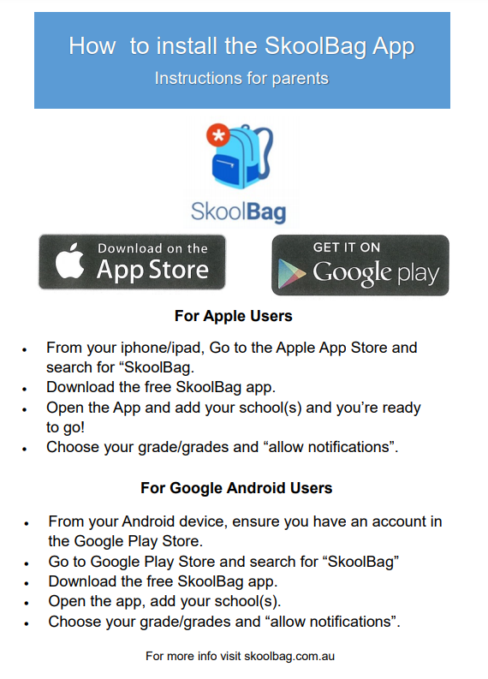

It is expected that parents inform us of any events which may impact their child at school, as well as any changes to drop off/pick up arrangements. Likewise, any incidents etc that occur at school will be communicated via app. Please use the communication book or email sarahjohnson3@education.wa.edu.au for all communication regarding your child.
Dalwallinu DHS has a private Facebook page. Please look for Dalwallinu DHS Parents and Families and like our page. Please notify the front office if you do not wish your child’s photo to appear on either of our Facebook pages.

News Sessions
News is an important part of our program and assists in boosting your child’s confidence, self-esteem and public speaking skills. Please refrain from sending in valuable or fragile items for news. All news items will be placed in a designated basket for safe keeping and returned to your child’s bag after the news session. Our news program will begin approximately half way through the year and will be held every day. Details regarding the news roster and weekly news topics will be sent home at a later date

Contact Details
It is important that our records are accurate. Please notify the school immediately if your address or phone number changes in case of an emergency.

Departure
Please pick your child up promptly from Kindy, as children of this age can easily become distressed when picked up late.
On Tuesday and Thursday we finish at 3:00pm. On Wednesdays the whole school has early close and children are to be picked up by 2.35pm.
If you are unable to collect your child from Kindy and have arranged for another adult to do so, please ensure that the staff have been informed with written permission. Children will not be dismissed to older siblings or other children unless written permission has been provided. Could all parents of bus children please advise staff of which bus their child needs to return home on. If there is any change of plan, parents are to inform the school prior to the end of the day. The Kindy Education Assistant will always walk bus children to the bus stop at the end of the day. It is the parent’s responsibility to notify the bus driver and the school of any change in their child’s travel plans.
If you are picking your child up during the day, please call past the front office to organise this.

Food
Children are required to provide their own crunch and sip, morning tea and lunch in a separate container, labelled with his/her name. Please ensure the food they bring is healthy.
Always include a bottle of water for the day; no drink boxes, cordial or soft drink.
Please send foods with your child to school that are free from peanuts, nuts and raw egg products.
Help for your child
We are always here to try and help you with problems concerning your child. We have access to a community nurse, Speech Therapist, Occupational Therapist, a school psychologist and other health professionals who may be able to help you if you have a problem. You don't have to cope alone.
Please let us know of anything that is happening at home which may affect your child's state of mind. If we know things are unsettled at home we can allow for children's behaviour at school.
If your child is currently getting help, please inform the teacher so we can support your child’s program.

Illness
Please do not send your child to school if unwell. If your child is unwell, the best place for him/her is at home with you. Please consider the other children and staff. It is not fair to spread germs to others.
If children are ill during the session the parent will be called to collect the child. In the event that the parent cannot be contacted, the emergency contact will be called to collect the child.
A child cannot be accepted into our care with any illness that may be transferred to others ie: conjunctivitis, chicken pox, colds and flues.

Leave Passes
All students at Dalwallinu District High School are required to attend the front office to collect a Leave Pass if they are leaving the school grounds during school hours for any reason. If parents are picking up their children during school hours they are required to present to the front office to sign their child out. Please do not go directly to the Kindy.

Library
Kindy children will visit the school library each week. Please take the time to share the book with your child and return it the following week. You will be informed of library days. Children will need a library bag to borrow a book.

Medication
If it is necessary for your child to take any medication during school hours, the parent/guardian must complete and sign the appropriate form before Administration staff will administer any medication. Medication should be in original containers with clear instructions for use. Please inform staff of any allergies your child may have. All parents will be required to complete a Medical Form at the beginning of each year and ensure the school is kept up to date with any changes throughout the year.

Monies
Could you please send any money requested (i.e. for Book Club) in an envelope with the amount, name and reason on the front. It would be appreciated if the correct money is paid as we do not have change on hand.

Parent Roster
Be actively involved, children love Mum or Dad to help on roster. You will also gain an insight into your child’s Kindergarten life and therefore, it will be easier to discuss the day’s activities after each session.
A parent roster will be displayed for you to add your name to from Week 5 onwards. Taking a turn on the roster is an important part of your child’s educational program as it allows you to become familiar with what we do and the programs we offer. It is also a special time for your child. Our roster usually runs on each day from 9.00am to 11.00am. All parents on roster are asked to visit the front office of the school to sign the visitors’ book before starting roster so Administration staff are aware of all visitors to the school.

Questions or Concerns
If you have any questions or concerns please come and speak with a staff member at your earliest convenience. We need to work together to achieve the best for your child.

Toys/Jewellery
Please do not let your child bring special toys or jewellery to school as it is quite upsetting if they are lost or broken. No responsibility will be taken for lost or broken toys or jewellery.

What Now?
*Show an interest in what is done at Kindy, especially any work that is sent home. Ask questions often.
*Praise all efforts.
*Send your child to Kindy regularly and punctually.
*Attend parent rosters as many times as you are able to.

