2023

DALWALLINU

District High School

Educating students from Kindergarten to Year 12
Parent Handbook
CONTENTS

INTRODUCTION…………………............................................................................... 2
DDHS BELIEFS………………………………………………….….............….2
SCHOOL CONTACT DETAILS……………………………………………………………......... 3
SCHOOL DATES…………………………………………………………………………………… 3
HOW TO ENROL………………………………………………………………………………….. 4
STUDENT CARE…………………………………………………………………………………… 5 - 8
ATTENDANCE……………………………………………………………………………............ 8 - 9
STUDENT BEHAVIOUR………………………………………………………………… ………. 9 - 10
PARENTS AS PARTNERS……………………………………………………………………….. 11 - 12
PARENT/SCHOOL COMMUNICATION………………………………………………………. 12 - 13
COMPLAINTS PROCEUDRES.……………………………………………………………....... 14
GENERAL INFORMATION…………………………………………………………………...... 15
AIEO Assemblies
Buses
Camps/Excursions
Chaplain
Class Structures & Teaching Staff
Contributions & Money Collection
Insurance
Lost Property
Lunches
Mobile Phones
Publication of Student Images and Work Pupil Requirements
Pupil Requirements
School Dress Code
School Policies and Procedures
Visitors to the School
ACADEMIC PROGRAM………………………………………………………………………….. 25
SECONDARY CURRICULUM…………………………………………………………………… 27
Our Curriculum……………………………………………………………………………………28
Beyond Year 10………………………………………………………………………………….. 29 - 30
Compulsory Subjects…………………………………………………………………………… 31
English Learning Area………………………………………………………………………….. 31
Mathematics Learning Area…………………………………………………………………...32
Humanities and Social Sciences Learning Area……………………………………….....33
Science Learning Area…………………………………………………………………………. 34 - 35
Vocational Education…………………………………………………………………………… 35
Health and Physical Education………………………………………………………………. 36 - 37
Optional Courses………………………………………………………………………………… 37 - 39

INTRODUCTION
The Dalwallinu District High School (DDHS) community welcomes all parents who will be associated with our vibrant school. We take pride in our excellent facilities, our openness to new ideas and new people, our quality learning opportunities and our care for our students.

The teachers at Dalwallinu District High School are well qualified, experienced and dedicated. Teachers are constantly exploring better ways to help your child learn, and value your role as the parent educator. You can be assured that your children’s best interests are our prime motivation.

The importance of home and school working together to provide children with supportive care throughout their primary and secondary schooling cannot be emphasised enough.

At DDHS we work hard to provide a high quality education for every child; however we can't do it alone. We encourage you to be involved in the work of our school, in the classroom, at P&C meetings, the School Council and at home with your child. Research clearly shows that parent and community involvement in schools improves student achievement. To reach their potential, students need parents, and the community, to take an active role in their education.

This booklet will assist you to gain a better understanding about the way Dalwallinu District High School operates but please feel free to contact us if you wish to know more. Your child’s teacher or our friendly office staff can answer most of your questions or concerns.

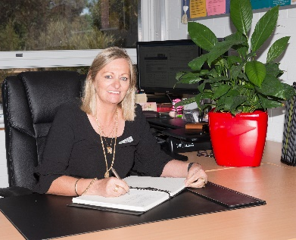
Petrina Bean
Principal
Dalwallinu DHS

OUR BELIEFS
- To provide a safe, supportive and accountable learning environment that ensures students achieve their academic, social, emotional, physical and creative potential.
- The mental, physical health and well-being of students and teachers is a priority.
- Effective teaching has high expectations of students, is purposeful, challenging and connected to student experience, stage of development and background.
- To develop and foster a shared understanding that effective education is the responsibility of, and a partnership between the students, parents, the school and the community.
- Learning programs need to acknowledge and build on where students are at with their learning. They need to be culturally and developmentally appropriate and have real-life application.
- Effective learning occurs where the school and community have a common goal, interact positively and are mutually supportive of each other’s priorities, initiatives and cultures.

SCHOOL CONTACT DETAILS
For all enquiries, please first contact the School Reception. Reception at the School is open between the hours of 8:00am and 4.00pm, Monday to Friday during school terms.
The office will reopen for 2023 on Wednesday 25th January.

T: 08 66611500
E: Dalwallinu.dhs@education.wa.edu.au

Administration Staff:
Principal: Petrina Bean

Deputy Principals: Melissa Harms - Primary
William Stewart - Secondary

Manager Corporate Services: Jenny Sawyer

School Officer: Rachael Lehmann

SCHOOL COMMENCES 8.50am

Period 1 8.50am – 10.00am
Period 2 10.00am – 11.00am
RECESS 11.00am – 11.20am (20 mins)
Period 3 11:20am – 12.10pm
Period 4 12.10pm – 1:00pm
LUNCH 1.00pm – 1.35pm (35 mins)
Period 5 1:35pm – 3:00pm
DAY CONCLUDES 3:00pm with the exception of Wednesday which concludes at 2:35pm

DATES FOR 2023

Term Dates:
Term 1 – Wednesday 1st February – Thursday 6th April
Term 2 – Wednesday 26th April – Friday 30th June
Term 3 – Monday 17th July – Friday 22nd September
Term 4 – Monday 9th October – Thursday 14th December

School Development Days –
- Term 1 – Monday 30th January and Tuesday 31st January
- Term 2 – Monday 24th April, Friday 2nd June (prior to long weekend to tie in with boarders)
- Term 3 – Wednesday 30th August (Dowerin Field Day)

Public Holidays
- Monday 6th March – Labour Day
- Friday 7th April – Good Friday
- Tuesday 25th April – ANZAC Day
- Monday 5th June – WA Day

HOW TO ENROL
To enrol at Dalwallinu District High School (DDHS) there are a number of eligibility requirements.

AGE & IMMUNISATION CONFIRMATION
A birth certificate or extract of birth or passport and a copy of each student’s immunisation records must accompany the Application for Enrolment. Students will be placed in the year of study corresponding to their age group.
An application for enrolment must be completed by parents/guardians 24 hours prior to student placement in class. For all reporting purposes the legal name will be the name used on all formal documentation.
Enrolment at this school means acceptance of, and compliance with, the policies outlined in this handbook. Parents who would like to help develop or alter policy should contact members of the School Council or the Principal.

Name changes for students are acceptable if you have any of the listed documentation. The Department of Education’s Family Law Issues in Schools policy effectively states that the student enrolment card and all other school records should indicate the students ‘legal’ name. The student’s legal name usually appears on the student’s Birth Certificate. It is the name under which the student is officially enrolled. If however, any of the following conditions apply; schools can enrol students under an alternative name or change existing records to indicate the new name:
- A signed consent from both parents indicating approval to use the new name
- A Family court order authorising the use of the new name
- A change of name certificate, issued by the Registry of Births, Deaths and Marriages authoring the new name
- Additional, in respect of a student who is 12 years of age or more, the student should consent to the change of name.

SPECIAL NEEDS
Parents of students with special needs are asked to contact the school to discuss these needs when the Application for Enrolment has been approved to ensure that the most appropriate program is in place to meet the child’s needs.

OVERSEAS STUDENTS
Students who were born overseas must hold the appropriate visa before applying at the school.

EMERGENCY CONTACT
In the event of a child becoming ill or being injured at school, the emergency contact name and phone number as entered in the Enrolment Card will be used.
Please ensure that the following details are kept up to date on your child’s Enrolment Card and you notify the school of any changes.
- Your address and phone number
- The name, address and telephone number of a contact person in case you are unavailable.
- The name, address and telephone number of your doctor
- Any allergies such as bee stings, which affect your child, and any medication required.
- Emergency care plans for students with known medical conditions that require interventions, such as asthma.

CHILDREN TRANSFERRING
Parents are requested to give us one week’s notice in writing when children are about to leave our school or transfer to another school. This will provide adequate time to enable the staff to ensure that all records, books, medical cards, reports etc have been completed or checked prior to the child’s departure.
STUDENT CARE

ACCIDENT OR ILLNESS
Minor accidents are treated at school. In cases of more serious accidents or your child becomes ill, we will contact you at once. All injuries to the head will prompt a call to parents to pick up their child for further investigation. Please ensure that we have up to date contact information. It is most important to have an emergency number to ring. Children who are obviously ill before school should not attend. As only basic facilities are available at school for children who become ill, parents will be contacted and asked to take the child home as soon as possible.

BICYCLES, SCOOTERS AND ERiders
Students are encouraged to ride bikes or scooters to school. There are bike racks available for student use. At no time should students be riding their bikes or scooters through school grounds.

It is a parental responsibility to ensure that every child who rides to school wears a helmet.

The legal minimum age to ride a eRider is 16 years of age. Children under 16 are permitted to ride low-powered electric scooters which do not exceed 200w or 10km/h.

CHILDREN’S BELONGINGS
Children are discouraged from bringing anything of value to school due to accidental damage or loss and the stress this causes. This includes jewellery, money, sporting equipment etc. Mobile phones are important modern day communication tools, essential in providing a safe and effective school environment. However, they can easily be improperly used, lost or damaged and must therefore be effectively managed. Student’s mobile phones are to be left at the front office at the beginning of the day and collected once school finishes in line with the DDHS Mobile Phone Policy.

DENTAL THERAPY UNIT
The Dental Therapy Unit provides a free, continuous preventative dental service for each enrolled child from Pre-Primary to Year 10. The Dental van visits Dalwallinu on a biennial basis.

HAIR
Hair that reaches the shoulders, or is longer, must be tied up at all times. Head lice do occur from time to time in the school and this is one way of alleviating the problem. Parents are asked to check their child(ren)’s hair every Friday evening so that any problems can be treated over the weekend, thus avoiding absence from school. If all parents take this course of action we will minimise the spread of head lice. Health Department fact sheets are available from the front office to assist with treatment.

HEAD LICE
Due to the proximity in which children play and work together at school, it is likely that head lice will pass from one child to another. A child found to be infested will not be permitted to return to school until he/she has been treated. All eggs must be removed. When a student has been sent home for treatment, it is important that the school is satisfied that the treatment has been carried out and it has been effective. Please see the DDHS Head Lice Policy for more information.

MEDICAL POLICY
It is a policy at our school that on enrolment all parents complete medical information on the Enrolment Form for their child(ren) and that this information is kept up to date. We need to know of any allergies your child may suffer from so that we can give the best possible First Aid in an emergency and know when to seek medical assistance. The School Administration must also be made aware of any student who self-medicates e.g. Ventolin for Asthma.

MEDICATION
Staff will assist parents with reasonable requests for the administering of prescribed medication where there is an agreement between staff, parent/guardian/carer, and Principal, and where written instructions from the prescribing doctor have been provided by the parent/guardian/carer. School Staff are responsible for student welfare and need to know if a student has a valid medical reason for carrying prescribed medicine to school.
Where a child has brought medicines/tablets into the school without ratification from parents, teachers will take possession of the medication then contact parents for clarification of the child’s needs.
Students should self-administer their own medication where capable of doing so, and have authorisation for the taking of his or her medication. The students may be supervised/assisted by school staff in administering their medication where there is an agreement to do so.
If a student is required to carry and self-administer prescribed medicine while at school, the parent/guardian/carer must advise the Principal of all relevant details, e.g. What form the medication takes, the correct dose and the symptoms associated with misuse, overuse, or underuse as indicated by the treating doctor.
Students are NOT to keep medication (prescribed or non-prescribed) in their bags.
Administering Over-the-counter (non-prescribed) Medication is not the responsibility of staff.
School staff will not be involved in administering non-prescribed medication.

MINOR ANALGESICS

Analgesics are non-prescribed pain suppressants (e.g. Aspirin, Paracetamol) and can have undesirable side effects. Aspirin will not be administered to students without a medical practitioner’s written instruction.

If school staff are to administer medication to the student the following protocol applies:

Parent/guardian/carer must provide written authority for the staff accepting responsibility to administer the prescribed medication.

Parent/guardian/carer is responsible for the submission in writing of any requirements of the student for medication, including details from the medical practitioner and of the circumstances for the appropriate use and application of the medication.

Parent/guardian/carer must provide the medication in a properly labelled container (name of student, name of medication, doses to be taken). Minimal quantities only should be sent to school unless there is a need for larger amounts to be sent, by agreement with the school. Medication that is not labelled correctly will not be accepted for use.

School staff will only administer prescribed medication in accordance with instructions or advice of a medical authority.

A new request/record agreement needs to be made:

* if the dose or medication is altered

* if the regime is re-started following the expiration of this order

* at the beginning of each NEW calendar year

* if the designated teacher alters

PARENTS & VISITORS ON THE SCHOOL GROUNDS
For the safety of the children, the school insists all visitors, parent classroom helpers etc. enter the office to sign in. This also assists Admin to know how many people are on school grounds in case of an emergency. Parents are to drop lunches etc. at the front office where students will be called to collect via the public announcement system. Similarly, if collecting your child for an appointment etc., please report to the front office and your child will be called to meet you there. Under no circumstances are parents to visit classes without notifying the front office during school hours. This is in line with the Department’s Visitors and Intruders on School Premises Policy.

If parents need to pick their child up early due to sickness or an appointment, then they must sign the Student Departure Book in the office.
SAFETY WHEN SETTING DOWN OR PICKING UP STUDENTS
Motorists should be considerate in parking when depositing or collecting children. Parents are able to reverse park in the Northern car park if accompanying their children to class. There is also a kiss and drop zone on the south – west corner of the school near the basketball courts. Bus students will be picked up and set down on the southern side of the school on Owens Ave. Students are assisted when walking home and crossing this street. Please DO NOT drop off or pick up students at the front of the school. This is for staff and visitor parking only.

SCHOOL EVACUATION PLAN
The school has an evacuation plan in case of fire, earthquake, bomb threat or other emergencies. A copy of this plan is in all classrooms and accessible to all on the premises.
SCHOOL HEALTH NURSE
A trained nursing sister visits the school throughout the year and is available to discuss health matters with parents / caregivers whose children need assistance. An appointment can be made through the school or by contacting the Dalwallinu District Hospital on 9661 0200. A health assessment is carried out on children in Pre-Primary, or Year 1 if they missed the PP check. Vision screening is done on Year 6 students.

SICKNESS
Parents are asked not to send children to school who are obviously unwell. They can become very distressed and when this occurs, valuable time is spent contacting parents to have the child picked up or, in the extreme, where parents cannot be contacted, the school has an obligation to engage medical authorities to deal with the matter.

STUDENT SERVICES: EDUCATIONAL PSYCHOLOGIST
The services of an Educational Psychologist are available to the school. Children may be referred by the school or by parents. Information about referral procedures may be obtained from the Deputy Principal.

WEARING HATS - NO HAT- NO PLAY
The school has developed a policy to reduce the impact of skin cancer in children in line with the Department of Education’s policy and through collaboration with the P&C Association, the School Council and staff. Children will only permitted out in the sun if they are wearing a hat. This policy will apply year round for morning recess, lunch-time, sports afternoons, PE periods and excursions.
INFECTIOUS DISEASES
Chicken Pox… Exclude from school for at least 5 days after the rash appears and until vesicles have formed crusts. Some remaining scabs do not justify continued exclusion.
Conjunctivitis… Exclude until discharge from the eyes has ceased.
Measles… Exclude from school, re-admit on medical certificate. Parents are asked to notify the
school immediately a diagnosis is confirmed by their family doctor. Unimmunised contacts should be excluded until 14 days after the first day of appearance of the rash in the last case identified in the school, unless contact was immunised within 72 hours of first exposure. Contacts should be advised to see their doctor immediately.
Rubella (German Measles) …Exclude from school. Re-admit on recovery or until at least 4 days after onset of rash. If in contact students do not need to be excluded but should be advised to see their doctor.
Mumps…Exclude for at least 9 days after onset of symptoms. Contacts should be advised to see their doctor.
Hand, Feet and Mouth Disease…Exclude until all blisters are crusted.
Impetigo (School Sores) Exclude for 24 hours after antibiotic treatment commenced. Lesions on exposed skin surfaces should be covered with a waterproof dressing.
Hepatitis A…Exclude from school. Re-admit on medical certificate of recovery but not before
seven days after onset of illness.
Ring Worm…Exclude for 24 hours after treatment has commenced.
Herpes Simplex (Cold Sores) …Young children unable to comply with good oral hygiene practices should be excluded while lesions are uncovered or weeping. Lesions should be covered by a dressing, where possible.
School Sores…see Impetigo above
ATTENDANCE
Punctuality and regular attendance assist individual and class progress. If it is necessary for a child to be late, or absent, a brief written explanation is required containing the following information:
- date of absence
- child’s name
- child’s class
- reason for absence
- signature of parent or guardian
Attendance of students in years PP – 12 is compulsory. Once Kindergarten children are enrolled their attendance is then considered compulsory as well. Recent research from the ‘Every Day Counts’ report (commissioned by the University of Western Australia’s Telethon Institute For Child Research for the Department of Education) very clearly highlights the close relationship between attendance and academic progress. Barring legitimate illness, which the school is sympathetic to, all students should aim to attend school as close to 100% as possible. It is critical that students at Dalwallinu DHS attend well. Absences for reasons such as birthdays, rest days, catching up with family member days, appointments that could be made out of school hours, holidays during term time etc. should be avoided. As always, in cases of absence, we encourage parents to call as soon as possible to alert the school. Under Department of Education Policy, all absences require an explanation. If you have any issues with the attendance of your child please contact the school for support. Missing School = Missing Out
Under the provision of the Education Act, daily attendance of pupils is compulsory until the end of the year they turn seventeen. You can notify the school in advance or on the day of the absence before 9.15am on 96611204 or SMS 0437153176 to explain why the student is away. If the student is going to be absent for more than two days, parents should advise the school during the period of absence. Students who have frequent or prolonged absences are monitored and reported to the District Attendance Officer. A letter will be sent home requesting an explanation if the above is not done.

EARLY ARRIVALS
Children are discouraged from arriving to school before 8:30am each morning unless they are scheduled to participate in an organised school activity. Before 8:30am teachers are busy preparing for the school day and are not able to supervise the students. Students that arrive at school before 8:30am are required to sit in the undercover area.

LATE ARRIVALS
If your child is late for school, they must be signed in at the front office before going to class.

PARENT NOTES
Are requested for:-
- Daily absence from school - Absentee Notes. The Department of Education requires a reasonable explanation for each absence. All absences must be explained by a written note to the class teacher or a telephone call to the office. If students are absent, and the school has not been notified, a message is sent to parent’s mobile phones via the Message U service. Please respond to these messages ASAP. If absences are not explained, then a letter or phone call home will occur.
- Exclusion from Sport, Physical Education, Swimming - for medical reasons.

STUDENT BEHAVIOUR
BEHAVIOUR MANAGEMENT AND EDUCATION PLAN
Our school staff, with the support of the School Council, has developed a consistent and responsible Behaviour Management Plan (BMP). Sitting alongside our BMP is the Good Standing Policy whereby students need to maintain ‘Good Standing’ to enable them to participate in extracurricular camps and activities e.g. DHS Country Week, sporting events etc. Interested parents may obtain a copy of the Managing Student Behaviour Policy & anti-bullying procedures, as well as the Good Standing Policy from the School Office.

The school plan takes into account the differences and diversity within the school community and a restorative problem solving approach is used across the school to address inappropriate behaviours. A Code of Conduct is in place to ensure a safe working environment for all students and staff. Breaches of the Code of Conduct result in appropriate sanctions being applied in line with the Department of Education’s Policy. Parents will be contacted if their child deliberately or repeatedly displays unacceptable behaviour at school.

Parents are asked to always inform class teachers if anything happens outside of school that might impact on their child’s behaviour at school.

The school has a positive approach to discipline where the students are encouraged to learn self-discipline in our friendly and harmonious atmosphere. The restorative approach allows students to consider the consequences of their negative behaviour to others, the harm that has been done and the actions they will take to make up for it. Praise, rewards and privileges are all used as children develop their sense of socially acceptable behaviour.

ANTI BULLYING POLICY
Dalwallinu District High School is a Bully Free Zone. Bullying of any type is not tolerated. It is important for children to understand that they must tell an adult if they have been bullied or if they see someone else being bullied. All reported instances of bullying will be acted on by school staff.

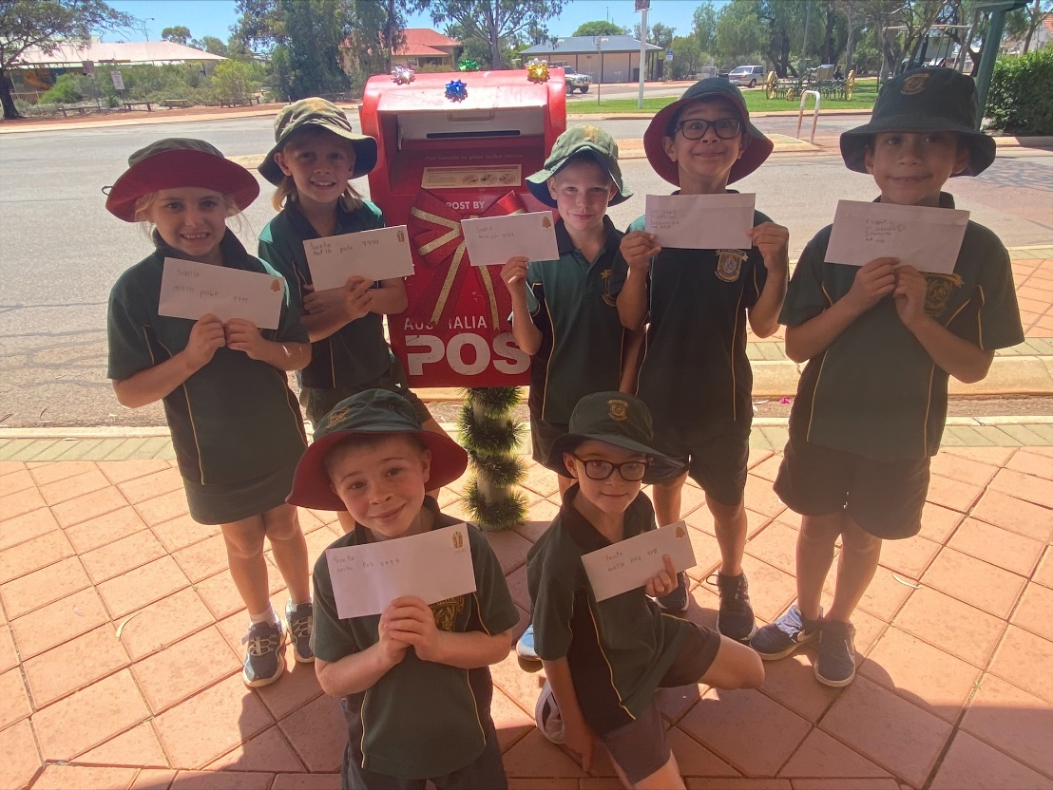
PARENTS AS PARTNERS
There are many ways parents and other adults who play an important role in a child's life can be involved with their children's education at home, at school and in the community.

As a parent, or an adult who plays an important role in the life of a child, your involvement in your child's education at school and at home shows your child that you value education.

Teachers can see that you care about your child's learning. You can provide teachers with the most reliable source of information about your child. The partnership between you and your child's teacher is a powerful one.

Here are some ways you can be involved in your child's education each year at school:

- Meet the teacher - Tell them about your child's interests and hobbies. Let them know how and when it is best to reach you. Ask them how you can support your child’s learning at home.
- Arrange an interview with your child’s teacher through the school office to discuss academic progress, behaviour or any concern you may have. Our teachers are happy to take time to talk with you. It is important to make the effort to get to know your child’s teacher early in the year. Let them know how they can contact you if you are working. Making the effort to talk with the teacher shows your child that you value what happens at school.
- Come to P&C Association Meetings - Attend meetings, usually once per term, during the school year. The P&C supports the school in many ways and all parents and interested parties are urged to attend these meetings. As a group, see how you can help the school reach its goals.
- Volunteer your time to help at school. Even working parents are able to spend some time helping at school. Taking a day off work to help at a sports carnival shows your child that you think school activities are important.
- Stay up-to-date on school policies, schedules and rules. Ask about opportunities to participate in the development of school policies. Discuss the policies with your children and other parents.
- Contact your child's teacher if you have any concerns about what's going on with your child at school. Don’t only discuss problems with other parents outside of the school. Be fair and get all sides of the story. Talk with the teacher first and then follow the correct process if you need to get more information or make a complaint.
- Know your parent representatives on the School Council and express concerns and issues to them for discussion at School Council meetings.

SCHOOL COUNCIL
The governing body at the school is the School Council which has a majority parent representation.
The School Council meets twice/term. The functions of the Dalwallinu District High School Council are:
- To take part in:
a) establishing, and reviewing, from time to time, the school objectives, priorities and general directions.
b) the planning of financial arrangements necessary to fund those objectives, priorities and directions.
c) evaluating the school’s performance in achieving the above.
2. To promote the school in the community.
3. To take part in formulating codes of conduct for students at the school.
4. To determine, in consultation with students, their parents and the staff of the school, a dress code for the students when they are attending or representing the School.

The School Council is made up of: -
* Parent representatives * Staff members
* The Principal * Community representative(s)

PARENTS AND CITIZENS ASSOCIATION (P&C)
The DDHS P&C is made up of parents interested in the best possible education for their children. It raises money to provide learning opportunities for the students and is a forum for discussion about our school. You will be most welcome to bring your ideas, questions and enthusiasm to the meetings. Regular meetings are held each term, Please check the school calendar for dates or refer to the newsletter.

Our P&C operates the School Canteen, which is open 5 days a week to provide nutritious lunches and morning teas to students and staff. School uniforms are also available through the canteen.

PARENT / SCHOOL COMMUNICATION
Close home/school contact is essential for your children to progress and reach their potential.

Teachers welcome the assistance of interested parents in classroom activities such as listening to reading, assisting with Maths, Science or Art/Craft activities, sharing special skills and assisting the Librarian by covering books.

PARENT/COMMUNITY MEMBER HELPERS
Parent help is encouraged through the school. If you would like to assist, please contact individual class teachers. For community members to work with children a Working with Children Clearance Card must be presented to the school. Parents do not need a Working with Children Clearance unless they are going to be staying overnight on a camp or excursion.

NEWSLETTERS & NOTES
To keep you informed, a newsletter is sent home via the Skoolbag App. The newsletter provides a wide variety of information concerning school programs and activities. Frequently school articles are published in “Totally Locally” to provide notice of events and other information, as well as acknowledge student achievement to the general public.

At the beginning of each Term, a planner will be issued. Every fortnight there are Diary Dates advertised which provide a reminder of upcoming events.
SPARE COPIES OF THE NEWSLETTER ARE ALWAYS AVAILABLE FROM THE OFFICE

The formal staff/parent communication channels are the School Council and the Parents and
Citizens Association. They provide a forum for school policy matters BUT NOT for the discussion of personal issues, which should be raised with the class teacher or Principal.
We also have a school Facebook Page which is used to promote and inform the community of happenings within the school.
WEBSITE & SMART PHONE APP
Skoolbag is a school Mobile App that communicates directly with iPhone, and Android devices.

Our app is designed to make communication with parents and the larger community more effective. The app is intuitive and will allow you to receive important alerts, school newsletters, general school news and information targeted to your specific school circumstance e.g. if there is an issue with one particular bus, only parents of students on that bus would receive the alert.

PARENT / TEACHER INTERVIEWS
It is important that parents take the opportunity to discuss their children’s progress with the class teacher on a regular basis. Parents wishing to have a formal discussion with teachers should make contact to arrange a suitable time. Parents are requested not to seek lengthy discussions with the teacher without making a prior appointment. Teachers cannot hold such discussions during teaching time, or before school when they are busy preparing for the day’s work. Formal Parent / Teacher interviews will also be offered during the year.

PARENT TEACHER COMMUNICATION

If you have a concern please speak to the teacher first. If the issue is not resolved after several conversations, then please speak to the Principal. Serious concerns should be addressed to the Principal in writing. To be courteous, meetings with teachers or the Principal do need to be arranged in advance.

All communication between parents and students, during school hours, should occur via the school’s administration. To protect the privacy of teachers and to ensure that they are teaching and not answering text messages during learning time, the preferred method of contact to school if your child is absent, or you need to convey information, is to phone the Admin Office (08 666 11 500). Alternatively, for absentee notes, parents can use SkoolBag, by phoning the front office or by emailing Dalwallinu.DHS@education.wa.edu.au. If you wish to speak to a teacher, please make a scheduled interview appointment, please phone the front office.
The Principal and staff mobiles are private numbers and may be used only in an emergency or on an excursion, camp etc.

REPORTS ON STUDENT ACHIEVEMENT
In line with the school’s Assessment and Reporting Policy the school will issue two formal reports for students. Term 2 – Semester One Report and parent interviews. Term 4 – Semester Two report.

It is important that all parents endeavour to meet the teacher early in the year. Please make the effort to arrange a mutually convenient time so that you can share your knowledge of your child and in doing so help the teacher understand them better and cater for their individual needs.

COMPLAINTS PROCEDURES
It is acknowledged that from time to time educational issues may arise for parents. These matters should be dealt with promptly so as not to hinder the student’s learning. Initially, these issues should be resolved at the classroom level; this is usually through the classroom teacher. Teachers will arrange meetings to discuss areas of concern with parents. If the issue is unable to be resolved, the parent may seek to lodge a complaint.

The Principal at Dalwallinu District High School is responsible for managing the resolution of disputes and complaints. Complaints will be resolved in a prompt and efficient manner so that we promote the highest standard of professionalism in dealing with our community. We will make every effort to promptly resolve disputes and complaints lodged with us according to the principles of procedural fairness.

Complaints can be made: verbally; by letter; by email; or by facsimile. Help is available at the school to support complainants to formulate, write and lodge a complaint.
Written complaints should be addressed:

“PRIVATE AND CONFIDENTIAL”.
The Principal - Dalwallinu District High School
97 Johnston Street
DALWALLINU WA 6609

Minimum information when making a complaint:
You should provide the following information when making a complaint:
- your name and contact details;
- copies of any relevant correspondence or documents relating directly to the complaint;
- the nature of the complaint; and
- what you consider is needed to resolve the complaint.

In the case of a verbal complaint, where you do not want to be identified or to lodge the complaint in writing, we will endeavour to work directly with you to resolve the matter.

Responsiveness:
We will acknowledge written complaints within 5 school days. We seek to resolve local complaints within 14 days. If, due to the serious nature of the complaint, it is deemed necessary to forward it on to another section of the Department, we will do so without delay. In all cases you will be kept informed of the progress of your complaint. You may enquire as to the progress of your complaint at any time by directly contacting the appropriate person. At the time of lodging a verbal complaint, or in the acknowledgment letter for a written complaint, this person will be identified for you. In the case of a verbal complaint we will advise you verbally or in writing of the outcome of the complaint. The outcome of all written complaints will be provided in writing.
When you are unhappy with the outcome of a complaint:
If you are unsatisfied with our attempts to resolve your complaint, you may wish to express your concerns to the Regional Director. To do this contact, in writing;
Mr Doug Cook- Regional Executive Director
Northam Regional Education Office
Northam WA
Complaints judged to be vexatious, trivial or without substance, will not be progressed. You will be advised of this decision in writing.

GENERAL INFORMATION

ABORIGINAL & ISLANDER EDUCATIONAL OFFICER (AIEO)

The main task is to provide support to Aboriginal students, particularly those students who are at risk with attendance, behaviour or achievement. These students require additional support to maintain their engagement in mainstream classes. The work will involve the presence of the AIEO in mainstream classes.

ASSEMBLIES
Whole school assemblies are held in the Undercover Area commencing at 9am. Dates of Assemblies are published in the school Newsletter at the beginning of each Term.
Assemblies are student centred, and facilitated by a host class and Student Councillors. Merit Certificates and other awards are also presented to deserving students by staff. Parents are most welcome to attend all assemblies. This is a chance for parents to have an informal chat with the Principal and Deputy and to meet other parents.

BUSES

Six bus routes operate for children living out of town. Parents must register their child in order to use this bus service by completing the relevant forms online at: http://www.schoolbuses.wa.gov.au (if unable to access the internet to apply, please attend the school for assistance).

Routes include: Kalannie
West Dalwallinu
East Dalwallinu
West Buntine
Latham
Jibberding

CAMPS AND EXCURSIONS

Camps are seen as a valuable educational experience which complements the work done in classrooms. From time to time teachers may choose to conduct a camp for their class. This may be all students in one-year level or parts of year levels where there are composite classes or the camp is special purpose across several classes. There is no guarantee every child will have the same camp opportunities as the decision to organise a camp always remains with individual class teachers.
Year 5 & 6 Students participate in an annual camp which is planned to visit Perth for 2023.
Country Week is an annual event where students from District High Schools meet and compete through various sporting events. All secondary students with ‘Good Standing’ are eligible to participate.

CHAPLAIN

The school has the services of a School Chaplain two days a week. Duties include:
- Participation in school camps, excursions, sporting events.
- Being available to talk with students and counsel them when requested.
- Providing pastoral care and advocacy.
Students are free to seek the services of the Chaplain without referral by a staff member.
The school's program of pastoral care is central to our aim of being a caring school. Our aim is to produce an atmosphere in which students and staff receive respect and recognition, "one from the other". The comparatively small numbers give each child a greater sense of being a unique individual.

CLASS STRUCTURES and TEACHING STAFF 2023
Primary: | Kindy | Mrs Sarah Dawson
 | Pre-Primary  Year 1 | Mrs Emma Jolly/Mrs Kirsten Strickland  Miss Abbie Freeman
 | Year 2 | Mrs Shannon Meeks
 | Year 3 | Mrs Shannon Turner/Miss Jess Olden
 | Year 4  Year 5  Year 6 | Mrs Leanne McAlpine/Mrs Hilary Dickins  Mrs Lesley Hasson  Mr Kurt Wade
Secondary:  Specialist &  Primary Support | English  Maths  Science  HASS  HPE  SIDE Support  Primary PE  Primary Science  Art  Manual Arts  Food Sciences  Languages | Ms Jane Cannon  Mrs Dimity Stewart  Mr Jordan Main  Mrs Bronwyn Hyde/Mrs Samantha Dickins  Miss Ellie Cusack  Mrs Samantha Dickins  Miss Ellie Cusack  Mrs Anthea Scholz  Mrs Helmi Seymour  Mr Greg McNeill  Mrs Amy Cail  Ms Lisa Malatesta

KINDERGARTEN
Kindergarten is a pre compulsory year of education. The program is available to children who turn 4 years of age by June 30th in the year they are to attend. Your child is about to start on an exciting learning journey that will help them reach their full potential in life. Kindergarten children attend three full days per week- Tuesdays, Wednesdays and Thursdays. Fully qualified staff ensure engaging and enriching programs are on offer. Once a child is enrolled in Kindergarten it is a requirement that they then maintain a regular attendance.

PRE – PRIMARY
Pre-Primary is a program that is available to all children who turn five years old by June 30th in the year they are to attend. Pre Primary is the first compulsory year of schooling.

At DDHS we value strong relationships between our school families and caregivers. Our parents and caregivers have much to offer the pre-primary and Kindergarten programs with their expertise, skills and knowledge. We appreciate the individuality of each child and the unique set of experiences they bring with them. Through interactive activities, new understandings are stimulated and with teacher guidance, become more complex and involved as time passes. Children and parents are encouraged to be actively involved in planning the learning environment.

Dropping off and Picking Up - Kindergarten and Pre-Primary Children:
Please make sure the children are delivered to and collected from the Kindergarten and Pre-Primary promptly. Regular attendance is important to ensure continuity in your child’s educational program. Please inform the school by phone or in writing if your child is absent.

For more detailed information please see the Kindergarten and Pre Primary Handbook 2023

CONTRIBUTIONS & MONEY COLLECTION
In accordance with the Department of Education Policy, we ask that School Contributions be paid as early as possible in the school year. The money is used to enrich the opportunities available to your child at this school.

The contribution rates, as set by the School Council, for 2022 are outlined in the Primary and Secondary Contribution Schedules.

From time to time it may be necessary for you to forward money to the school. Please place the money in an envelope marked with the child’s name, room number and what the money is for (e.g. swimming or excursions). Money is to be given to the class teacher before school.

INSURANCE

Many parents incorrectly assume that, should a child be injured at school, they will be covered by an insurance policy held by the school. This is, in fact, NOT true. Children are, of course, covered by Medicare which will cover most of the doctor's charges. Parents must take out their own health insurance if they wish additional cover. The only insurance cover held by the school is public liability. Claims for damages or expenses under this policy must be attributed to teacher negligence or faulty equipment.

LOST PROPERTY

Lost property is a major concern both to the school and to parents who have to meet the cost of replacing items lost. In order to address these concerns we ask parents to be very conscientious in the clear marking of names on all items of clothing, lunch and drink containers and stationery items. Labelled lost property will be returned to the owner. Every effort is made to locate owners of lost property. Clothing is held for three weeks and then passed on to new families seeking second hand clothing.

LUNCHES

Please label all lunch boxes and drink bottles clearly with your child's name and year level. All Primary students eat their lunch in the undercover area, supervised by a duty teacher, while Secondary students eat in the designated secondary eating area. Students are permitted to exit eating areas once finished eating and when the lunch area is clean and tidy. Students are not permitted to leave the school to purchase lunch, unless written consent has been provided to the school. Students who wish to go home at lunch time must provide a note and if this is to be a regular occurrence, one note to cover the year is sufficient.
CANTEEN AND LUNCH ORDERS

The Canteen is managed by the Parents and Citizens Association, and operated by Mrs Marilyn Brown, in consultation with the School.
The aim of our Canteen is to provide a service to Students and Staff so that they can purchase their food requirements on site. The canteen aims to sell food of high quality at reasonable prices, and wherever possible, healthy food choices are encouraged. Canteen is open daily, and orders are to be placed by 9.00am. The canteen complies with the Healthy Food Policy.

MOBILE PHONES

Our school has a mobile phone policy, which in summary is: “Students who bring mobile phones to school are expected to take the phone to the front office at the beginning of the day and collect from the same after school. Any mobile phone used during the day will be confiscated by the teacher with the expectation that the parent or guardian will collect the phone at their earliest convenience from the front office.”

PUBLICATION OF STUDENT IMAGES AND WORK

Dalwallinu District High School regularly uses images of students in a variety of ways to recognise excellent achievement, inform parents and the local community of school matters, publicise events and to promote the school. Parents are requested to sign a permission form giving permission for images of their children to be used. This information is kept on file in the Office. Parents can withdraw their consent at any time by contacting the school in writing.

PUPIL REQUIREMENTS

A stationary list is sent home at the end of each school year containing a list of student requirements for the following year.

SCHOOL DRESS CODE

It is government policy that each child wears the full school uniform. This is supported by the P&C Association and School Council of Dalwallinu District High School (optional for Kindergarten children). Our aim is to have all children take pride in their school and personal appearance. We ask for your co-operation in seeing that your child/children come to school clean, neat and tidy and wearing school uniform.

ALL STUDENTS
The uniform for all students consists of:

GIRLS
Check dress in Dalwallinu District High School fabric
Green/Black with Gold Pin Strip shirts
Bottle green shorts, pants, skirts or skorts (green tights may be worn during winter)

BOYS
Green/Black with Gold Pin Strip shirts
Bottle green shorts or pants
Green Dalwallinu District High School fleecy polo jumpers, or Green/Gold sports jacket
There are to be no visible additions to these items – no coloured garments hanging below the school shirt. Hoodies will not be accepted. If extra warmth is required, students can choose to wear appropriate undergarments (singlets, thermal underwear, etc).

FOOTWEAR

Fully enclosed school shoes, sports shoes/sandshoes, or strapped sandals. Thongs, boots and Ugg boots are all unacceptable.

HATS
Students are expected to wear the approved bucket hat when outside for recess and lunch times, excursions, Physical Education and Sport. Reversible Bucket hats in Faction colours are available for purchase through the School Canteen. Dalwallinu District High School is a Sun Safe school and the wearing of hats is expected all year round when outside.

JEWELLERY, HAIR AND MAKEUP

Modest and inconspicuous. Hair should be of a natural colour and not cut or dyed in a manner that draws unwarranted attention. Eg pink, blue, Mohawk. Long hair (hair below the shoulders) should be tied up for health and safety reasons.

EARRINGS

Students are not to wear earrings which could be considered a safety issue. The only acceptable earrings are studs or hoops which are sufficiently small that they cannot be accidentally torn from the ear.

BODY PIERCING

Body jewellery other than in the ears is discouraged. Should a student undertake to have piercing through places other than ears, there will be a need to ensure that Occupational Health and Safety issues are addressed. Students will be asked to remove or cover protruding jewellery that could be caught on clothing or pose a danger or threat to a child during school activities. Students who cannot comply with that instruction will be able to observe a lesson, but will not be able to participate.

UNACCEPTABLE ITEMS

Denim jeans of any colour (as per the Education Act), beanies, singlets, bandannas, jeggings, long sleeved tees or jumpers with/without hoods under the school polo shirt, tights/leggings under shorts or black tracksuit pants/shorts/skirts.

EXEMPTIONS

The Principal may exempt students from the School Dress Code upon written request from their parents or caregivers.

Grounds on which exemption may be sought include:

Religious

Cultural or ethnic

Itinerant students

Genuine medical or family sickness

Black tracksuits/shorts are not included in the School Dress Code Policy and will therefore lead to the following consequences.
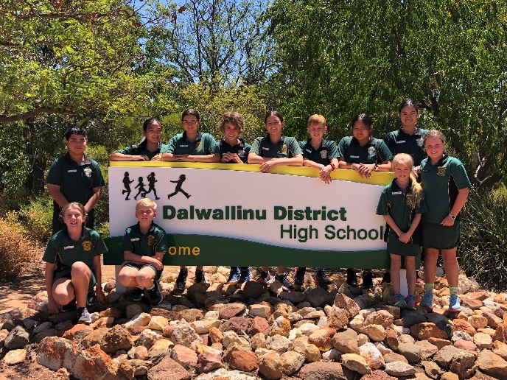

CONSEQUENCES

If out of uniform, students will be asked to attend the front office where they will be required to swap their non-uniform clothing for the correct uniform and return it to the office at the end of the day for washing. They will then receive their own item back.

If a student refuses this opportunity to change, they will be given some time to consider their choices, and then, depending on their choice, be asked to continue their work for the day in the Admin area as withdrawal from class. Parents will be informed. If a student becomes argumentative over the issue further behavioural consequences will apply and may result in a loss of Good Standing or restricted movement during lunch or recess.

The support you can give as a parent is to ensure that your child is equipped with full school uniform; including a jumper or jacket in Winter. It might be necessary for older students to work on managing the washing and drying (especially in Winter) so that they are available every day. It is only in the minority of cases, brought to the attention of an Admin member that a student will be exempt from the process. If this is the case, please phone the front office and speak with the Principal or Deputy Principal on 9661 1204 before school so this exemption can be arranged.

To ensure the safety of all students when they are away from school property, it is school policy that only students in school uniform may attend excursions; unless otherwise organised. Students out of uniform on the day of the excursion will remain at school with appropriate work.

Please note that if a parent is experiencing financial hardship and needs some support from the school in purchasing a school uniform for their child, you are very welcome to contact the school for this support.

SCHOOL POLICIES AND PROCEDURES
Dalwallinu District High School has a range of policies available. These are also issued to students as appropriate. Policies and procedures include:
- Assessment and Reporting Policy
- Managing Student Behaviour & Anti-Bullying Procedures
- Good Standing Policy
- Students at Educational Risk
- School Dress Code
- Students Online Policy
- Attendance Policy

VISITORS TO THE SCHOOL

All visitors, including parents, must register their presence at the school office before attending to their business within the school. Visitors spending time within the school must have a “Working With Children” clearance or sign a Confidential Declaration Form.

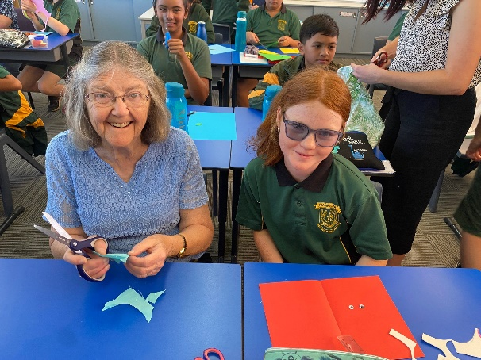

SCHOOL DRUG EDUCATION PLAN – Policy available
School Drug Education Guidelines
Our Vision
At Dalwallinu District High School, we believe that drug education is integral to the well-being of our students. We aim to provide a safe and supportive environment for the school community. We endeavour to engage the whole-school community in our drug education initiatives and are committed to providing our students with drug education and necessary related intervention across all year levels.

Curriculum
- We deliver age-appropriate drug education content across all year levels following the WA Health Education Curriculum https://k10outline.scsa.wa.edu.au/home/teaching/curriculum-browser/health-and-physical-education
- We use evidence-based drug education resources such as Challenges and Choices (www.sdera.wa.edu.au)
- School administration supports staff to deliver appropriate drug education by allowing in-school time for planning, providing professional development opportunities for staff and allocating funds for resources and materials.
- Classroom programs focus on skill development and develop students’ knowledge and understanding, attitudes and values and promote help-seeking behaviour.
- Learning is extended from the classroom to promote parent support of drug education programs (e.g. through communication to parents).
Ethos and Environment
- A CHAT committee is supported.
- Drug education is included in whole-school planning.
- All students have the opportunity to participate in drug education programs and initiatives.
- School administration supports staff attendance at professional development to broaden their understanding and enhance their confidence in working well with drug use issues.
- We have Procedures for Incident Management and Intervention Support and these are included for the community in this document.
Parents and Community
- Drug education information and strategies for parents and families are provided on a regular basis through a variety of methods such as the newsletter, website and at school assemblies.
- Orientation packs to new staff members and families include our School Drug Education Guidelines.
- Recommended websites are communicated via the Newsletter and school app.

Incident Management and Intervention Support
The following Incident Management and Intervention Support flow charts illustrate the steps which will be taken in the event of a drug use incident or issue. Should you wish to contact school personnel in this regard, contact details are provided.

Incident Management Flow Chart
Situation
Student/s are thought to be:
- drug affected
- in possession of a legal drug
- in possession of a suspected illicit drug.

Immediate Actions
- Keep calm and consider staff support
- Ensure safety of student
- Escort student/s for interview and hand responsibility to Principal and document details for the Principal ASAP
- The Principal informs student/s of concerns
- Principal gets the facts
- Principal, Staff Member or Chaplain follows up with other students involved as necessary

Intervention Support Flow Chart
Situation
Student drug use issue identified:
- through student disclosure
- through staff member raising concern
- as a result of a drug-related incident.

Immediate Actions
- Inform student/s of concerns
- Take matters seriously
- Get the facts
- Reassure student/s that their health and well-being are the primary concern
- Inform staff and document details
- Support student/s through referral process to appropriate staff members

Initial Follow-up Actions |  | Substance is a legal drug |  | Legal drug – Follow-up Actions
- Principal receives drug-related evidence – witnessed and documented  - Inform student/s of process  - Contact and involve parent/s  - Establish facts  - Determine further actions – following process for either legal or illicit drug use  - Consider need to send home  - Inform Senior Staff and Student Services Committee  - Document details/actions |  | - Substance is a legal drug being used on school premises where use is prohibited  - Substance is a legal drug being used by students who are under-age  - Substance is a legal drug being used outside the parameters of the intended purpose (e.g. use of a volatile substance or sale/inappropriate use of prescription medication) |  | - Consult with parent/s  - Determine actions  - Provide Intervention Support  - Document, monitor and evaluate
 |  | Substance is possibly an illicit drug |  | Illicit drug – Follow-up Actions
 |  | - Substance is an illicit drug  - Substance is suspected of being an illicit drug  - Substance is being represented as an illicit drug |  | - Report to Principal  - Police are notified  - Police conduct enquiries  - Illicit activity suspected  - Student searches required  - Nature of substance uncertain  - Determine actions  - Provide intervention support  - Document, monitor and evaluate

Disciplinary Interventions –  Follow-up Actions |  | Student Welfare Interventions –  Follow-up Actions
- Implement appropriate disciplinary actions (e.g. loss of privileges, detention)  - Suspension  - Suspension resolution  - Liaise with police  - Consult with parent/s  - Involve broader staff team  - Affirm student/s participation  - Document, monitor and evaluate |  | - Refer to support staff involved  - Ensure inter-staff communication and feedback  - Engage broader school support  - Communicate with parents  - Refer to external agencies  - Address illicit drug use if acknowledged  - Address Volatile Substance Use (VSU) if acknowledged  - Promote student autonomy  - Affirm student/s participation  - Implement student welfare strategies  - Document, monitor and evaluate

In the event of a drug use incident or where a student requires intervention for a drug use issue, the steps outlined in our flow charts for Incident Management and Intervention Support will be followed. In summary:
- the parent/s will be notified by appropriate personnel
- the Principal will consider notifying police if illicit drug use is suspected
- both students and parents will be offered support through appropriate interventions
- the incident or issue will be documented and other relevant agencies involved
- respect will be given to privacy and confidentiality by and for all parties
- the health and well-being of all parties involved will be given priority
Dalwallinu District High School does not permit students while on school premises, at any school function, excursion or camp to:
- smoke and/or possess tobacco products including e-cigarettes and other smoking instruments
- consume, possess or be affected by alcohol
- possess and/or use pharmaceutical drugs for non-medicinal purposes
- possess and/or aerosols as we are an asthma friendly school
- possess and/or use illicit drugs
- possess and/or use drug-related equipment, with the exception of for intended legitimate medicinal use

Useful contacts and information
Phone: (08) 666 11 500
Principal: Mrs Petrina Bean | The Holyoake Wheatbelt Community Alcohol and Drug Service Team  (08) 9621 1055
Deputy Principals: Melissa Harms  Bill Stewart | School Drug Education and Road Aware (SDERA)  08 9402 6415  www.sdera.wa.edu.au
School Health Nurse: Kate Kalem | Parent and Family Drug Support Line  Country free call 1800 653 203
School Psychologist TBA | https://drugaware.com.au/
Local Police Station: 9661 0444 | http://alcoholthinkagain.com.au

ACADEMIC PROGRAM
Staff at Dalwallinu District High School are dedicated to working in partnership with parents to ensure that the needs of every student are met. Teachers use a range of strategies to assist children who need extension or extra help. The environment continues to provide a strong whole school focus.

Regular Specialist Programs cater for:
- Auslan Years 3 -7
- Food Sciences
- Physical Education
- Visual Arts
- Manual Arts

These specialist programs are supplemented by external expertise in:
- In-term Swimming

PHYSICAL EDUCATION
Dalwallinu District High School has an active sports program. Primary students participate in faction and Interschool sporting carnivals. Secondary students participate in a program designed by our specialist Physical Education teacher. Games skills clinics are organised on a regular basis throughout the year and outside expertise through sports professionals is used to teach AFL, Soccer, Basketball, Hockey, Netball and Cricket when available. An in-term swimming programme for Years P-10 is also an important part of our curriculum.
All students are encouraged to play as much sport as possible, both for health reasons and to build sportsmanship and school spirit. The Physical Education program is compulsory and students will not be excused unless they provide a note signed by a parent or guardian giving a good reason. Students are required to wear appropriate sportswear when participating. When students use the Dalwallinu Recreation Centre for Physical Education lessons the school covers the cost for students.

SPORTS FACTIONS
Children are placed in a faction on admission to school. Family members are placed in the same faction. Others are placed accordingly to the balance of numbers.

We have three Factions – Xantippe, Petrudor and McLevie.
Children should always be appropriately dressed for sporting activities. Faction shirts may be worn on Physical Education class days. These are available for purchase through the canteen.

PEAC
Testing is undertaken in Year 4 to select candidates to commence involvement in Year 5 to attend regional based Primary Extension and Challenge courses.

TECHNOLOGY
Each primary and secondary class have Interactive Whiteboards, which are used as tools for learning. All students are taught computer literacy including the use of Microsoft Office applications, effective Internet usage, digital technologies and the use of educational software. DDHS has banks of desktop computers available for student use as well as laptops accessible to all. We have recently invested in purchasing iPads and currently have a 1:2 student ratio. We are investigating 1:1 in the Secondary area.

ENVIRONMENTAL RESPONSIBILITY
As part of our Values Education Program the school places particular emphasis on protecting our environment for the future. We regularly participate in environmental programs with local groups to revegetate and care for our surroundings.

LEADERSHIP PROGRAM
The Leadership Programme at Dalwallinu District High School offers all students the opportunity to develop, practice and demonstrate leadership, initiative and responsibility in all years of their schooling. There is one student councillor, elected by their peers, from each class, yr 5 – 10. with School Captains being selected from the year 9 and 10 cohorts. Faction captains are also elected. Students elected into these positions are also exposed to leadership opportunities within the Inland Lighthouse Network and will participate in a Leadership Day followed by an overnight camp when made available.

SECONDARY STUDENTS – YEARS 7 to 10
From 2015 all WA government schools transitioned year 7 students into high school. Year 7 students enjoy the benefits of secondary options and courses in an environment they are comfortable in after spending their primary years of schooling on the same campus.

YEAR 10 GRADUATION

This occasion is a highlight for our senior students and marks the end of their schooling at DDHS. The Graduation Ceremony is usually held in the last week of Term 4 with a formal dinner and presentation of awards and scholarships.

LIBRARY

Dalwallinu District High School Library is an environment designed to encourage recreational and curriculum related use by students. We provide a comfortable, relaxed and inviting environment for the students through the provision of sofas and activities such as board games.
A wide selection of fiction and non-fiction books and reference material is available and the use of the Library is encouraged. Children are made familiar with the borrowing system and in the Lower Primary it is recommended that only one book be borrowed at a time.

Library bags are required by all students if they wish to borrow library books. These bags are now available from the Canteen.
Students are encouraged to return their books to the Library, one week after borrowing. The following procedure is adopted for the recovery of overdue books:
- Up to two weeks overdue - student notified/reminded to return book.
- Over four weeks overdue - a letter is sent home to the parents concerned asking them to return the book.
- Parents are invoiced for the value of the lost book and the student will be unable to borrow library books until the account is paid.

Due to the high cost of books, careless handling and losses can easily lead to a situation whereby the library stock is steadily reduced instead of increasing each year. Parents can assist the school by checking on the books brought home and ensuring their prompt return in good order. Damaged or lost books will be replaced at the parent's expense.

SECONDARY CURRICULUM
Whilst we see Years 7 to 10 as preparing students for Upper School, employment or further training, it also serves to develop student’s interests and social skills.

We provide a rigorous curriculum that requires students to work hard and we have high expectations in terms of student work ethic, work output and standards of achievement. Our NAPLAN results for 2019 were very pleasing and we will continue to ensure that further improvement is sustained.

Through secondary options our aim is not to create expert artists or chefs, but rather to provide students with the opportunity to experience many different courses.

By providing this wide exposure to students they are more informed about their skill level, likes, dislikes and possible areas of interest. The more informed they are generally, the better equipped they are to make decisions regarding their futures in terms of further education and intended vocations.

Our school is well equipped and has specialist Design & Technology, Home Economics, Art, Science and Information Technology rooms. Our library is well resourced and students have the advantage of being provided with Laptops and iPads for use at school to reinforce educational outcomes in class.

We operate relatively small classes, which provide students with far greater opportunity for one to one instruction that enhances our ability to cater for the needs of individual students. Based on their ability and interests, students are well prepared for whatever their intentions are for further education, be it subjects leading to University, TAFE, Vocation Programs, Agricultural College, employment, traineeships or apprenticeships.
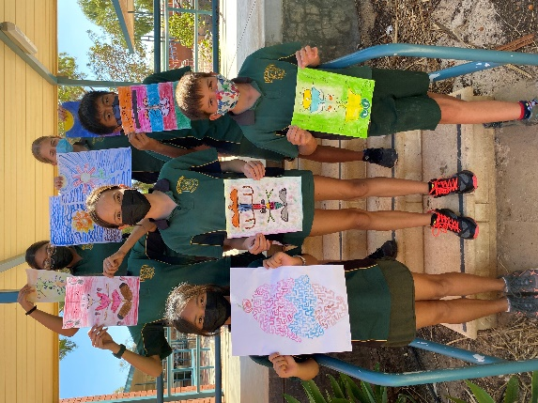
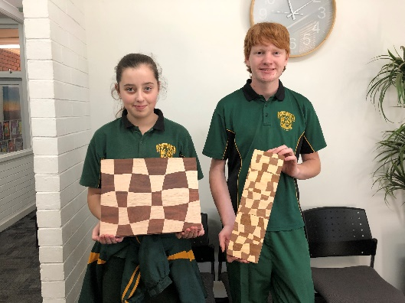
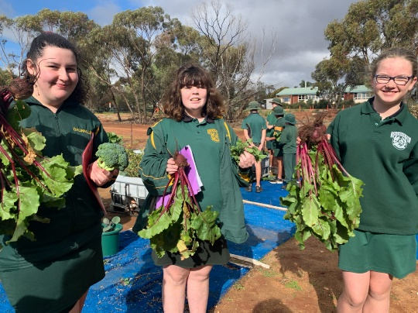

OUR CURRICULUM
The curriculum is divided into eight different LEARNING AREAS.

Within most of the learning areas there are sub-areas that are referred to as CONTEXTS, then within each of the contexts we have SUBJECTS.

BEYOND YEAR 10 -
All students who are of an age to be in Year 11 or 12 of schooling must be involved in either:
  - education at school (including a combination of school/training/work), or
  - other training (e.g. State Training Provider (TAFE colleges), traineeship or apprenticeship), or
  - worthwhile full time employment.
  - If you want to get a full-time job it must first be approved by the Minister for Education’s delegate, the Manager Participation.
  - In general you can only take a full-time job if it has long term prospects.

To achieve a Western Australian Certificate of Education (WACE) all students will need to be eligible for a university entrance rank (ATAR) or achieve a training Certificate II or higher.

WACE certificate also requires students to demonstrate a minimum standard of literacy and numeracy. This is attained by achieving Band 8 or above in their Year 9 NAPLAN tests, or otherwise they will be required to complete the Online Literacy and Numeracy Assessment (OLNA). Year 10 students sit this test in March. Students who have not met the standard will be able to re-sit the test in September.

In order for students to undergo a successful transition from Lower School (Year 10) to Upper School (Years 11 and 12), they will need to be aware that certain prerequisites in many subjects may apply. (For example, certain levels of achievement will be required in Year 10 English and Maths to attempt ATAR units in Year 11). Subject links to Year 11 Courses of Study are indicated throughout the prospectus.

To ensure that the Lower School student is given the opportunity to be exposed to appropriate Lower School subject content, a range of counselling opportunities are available at DDHS through:

1. Printed information
2. Vocational Education classes
3. Subject teachers
4. School Psychologist
5. Visiting guest speakers from TAFE, universities and other educational institutions, such as Morawa Agricultural College.
6. Visits to TAFE and Universities when available.
7. Support and guidance from our Engagement & Transitions Manager, Wheatbelt Regional Education Office.

Armed with this career information and with the knowledge and guidance of specific subject teachers in Lower School, students should become aware of the particular pathways and levels of achievement they need through Lower School to enable them to make a successful transition to Upper School.

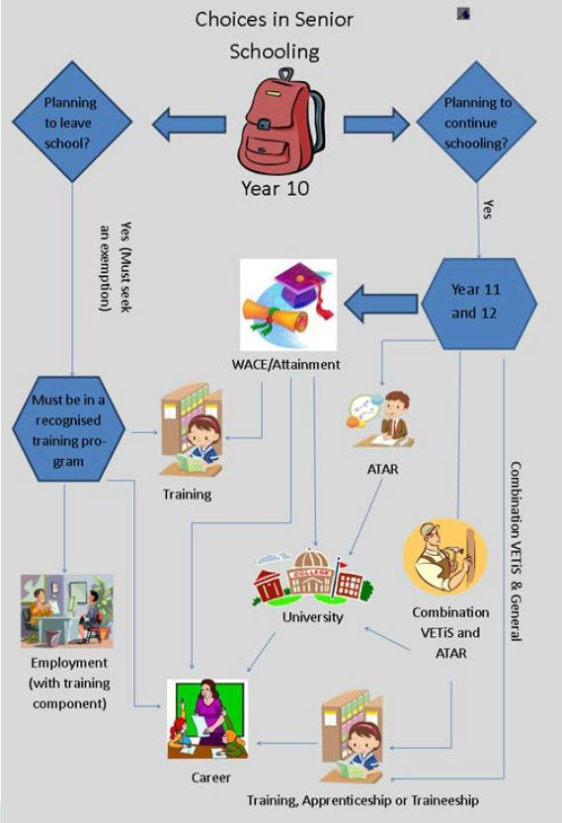

COMPULSORY SUBJECTS

ENGLISH LEARNING AREA
In the English Learning Area, students learn about the English language, how it works and how to use it effectively. They develop an understanding of the ways in which language operates as a social process and how to use language in a variety of forms and situations. They learn to speak, listen, view, read and write effectively.
Students in Years 7, 8, 9 and 10 are given the opportunity to demonstrate their individual level of skills and competencies in three inter related strands which develop students’ knowledge, understanding and skills in listening, reading, viewing, speaking and writing. Students develop their abilities in the three strands of:
Language: knowing about the English language
Literature: understanding, appreciating, responding to, analysing and creating literature
Literacy: expanding the repertoire of English languages.

It is recommended that those students who intend to undertake the ATAR should aim to achieve at least B grades by the conclusion of their Lower School education. Material content in the English Learning Area is covered and assessed in the three different Strands listed above.

Students also develop their Speaking and Listening skills through their participation in the annual School Concert and Assembly item

Related Year 11 Course of Study: English Foundations, English General, English ATAR.

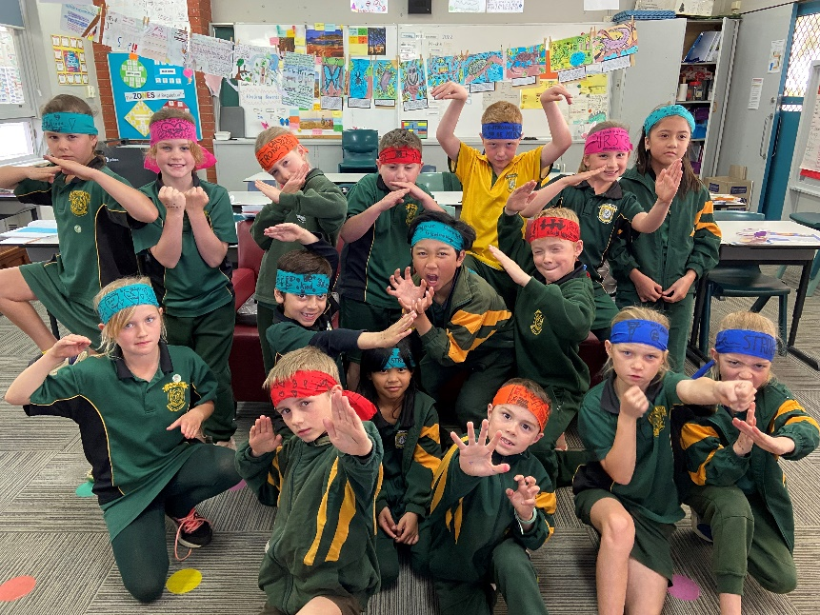

MATHEMATICS LEARNING AREA
Mathematics is an accumulation of facts, reasoning, strategies and number skills, which are applicable and necessary in the everyday world of survival, occupation and relaxation. A sound understanding of mathematical concepts and the application of them can widen the prospects available to students in later life.
The Western Australian Curriculum: Mathematics aims to produce students who are confident and creative in their use of mathematics to investigate, represent and interpret situations in their everyday lives. Students will develop understanding and fluency in each of the three content strand. There is also a focus on making explicit the links between mathematics and other disciplines and career options.

Content Strands
Number and Algebra
Students apply number sense and strategies for counting and representing numbers. They explore the magnitude and properties of numbers and apply a range of computations using the four operations. They understand pattern and use formulae to describe relationships and formulate generalisations. They recognise equivalence and solve equations and inequalities using both algebraic and graphical methods. Students apply their number and algebra skills to conduct investigations and solve problems.

Measurement and Geometry
Students develop their understanding of size, shape, relative position and movement of 2D and 3D objects. They learn to use patterns to develop geometric arguments and compare objects. They use appropriate units to make meaningful measurements of quantities. Students build an understanding of the connections between units and calculate measures such as area, volume, speed and density.

Statistics and Probability

Students can represent the possible outcomes of an event, and determine the likelihood of a particular outcome occurring. They assign probabilities using both experimental and theoretical approaches. Students develop an ability to analyse data using measures of centre and spread, and build skills to critically evaluate statistical information and develop intuitions about the validity of data.

Related Year 11 Course of Study: Mathematics Foundations, Mathematics General, Mathematics Applications, Mathematics Methods, Mathematics Specialist.

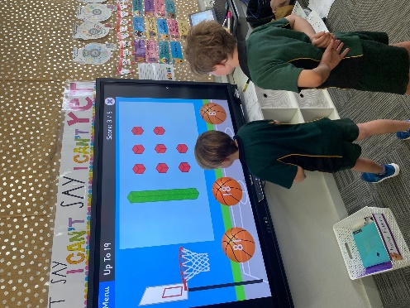

HUMANITIES AND SOCIAL SCIENCES LEARNING AREA
The humanities and social sciences are the study of human behaviour and interaction in social, cultural, environmental, economic and political contexts. The humanities and social sciences have a historical and contemporary focus, from personal to global contexts, and consider challenges for the future.

In the Western Australian Curriculum, the Humanities and Social Sciences learning area comprises four subjects: History, Geography, Economics and Business, Civics and Citizenship.

Through studying humanities and social sciences, students will develop the ability to question, think critically, solve problems, communicate effectively, make decisions and adapt to change. Thinking about and responding to issues requires an understanding of the key historical, geographical, political, economic and societal factors involved, and how these different factors interrelate.

The humanities and social science subjects provide a broad understanding of the world in which we live, and how people can participate as active and informed citizens with high-level skills needed for the 21st
Year Level | Year 7 | Year 8 | Year 9 | Year 10
Civics & Citizenship | Designing our political and legal system | Democracy and law in action | Our democratic rights | Justice at home and overseas
Economics & Business | Producing & Consuming | Participation and influences in the market place | Australia and the global economy | Economic performance and living standards
Geography | Water in the world  Place & liveability | Landforms and landscapes  Changing nations | Biomes and food security  Geographies of interconnections | Environmental change and management.  Geographies of human wellbeing
History | The ancient world Egypt, Greece, Rome, India, China | The ancient to the modern world | The making of the modern world | The modern world and Australia
century.
Related Year 11 Course of Study: Geography ATAR, Modern History ATAR, Certificate II in Tourism
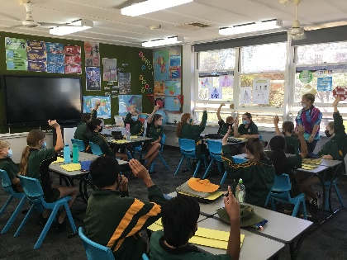

SCIENCE LEARNING AREA
In Science, students learn to investigate, understand and communicate about the physical, biological, chemical and technological world and understand the processes that support life on our planet. Science helps students to become critical thinkers by encouraging them to use evidence to evaluate the use of science in society and the application of science in daily life.

The Science Learning Area is divided into three interrelated strands: Science Understanding, Science as a Human Endeavour and Science Inquiry Skills. All strands involve both practical and written components, with Science as a Human Endeavour and Science Inquiry Skills being covered within the context of the four sub-strands of Science Understanding (Biological Sciences, Chemical Sciences, Earth and Space Sciences and Physical Sciences.) Students will, by the end of Year 10, have covered all outcomes.

Science Understanding
Biological Sciences
Students investigate living things and their interdependence and interactions within ecosystems. They explore how plants and animals possess features to aid their survival and how characteristics are inherited from one generation to another. Students are introduced to the cell as the basic unit of life and the processes that are central to its function.

Chemical Sciences
Students classify substances according to their properties or composition and explore physical and chemical changes. Students recognise that all substances consist of atoms and that chemical reactions involve atoms being rearranged and recombined to form new substances. They explore the relationships between atomic arrangement and properties, as well as the effect of energy transfer on these arrangements.

Earth and Space Sciences
Students see Earth as part of a much larger system, and explore the immense scales associated with space. They relate Earth’s orbit and rotation to the seasons and day and night. Students investigate the processes that result in changes to the Earth’s surface and recognise that the Earth has evolved over 4.5 billion years. They explore resource use and the influence of human activity on the Earth.

Physical Sciences
Students understand that the motion of an object is influenced by a range of contact and non-contact forces. They understand the concept of energy and how energy transfer is associated with phenomena involving movement, light, sound, heat and electricity.

Science as a Human Endeavour
Nature and development of Science
Students appreciate science and scientific knowledge, including how current knowledge has developed over time through the actions of many people.

Use and influence of Science
Students investigate how science knowledge and applications affect people’s lives and work, and how science influences and is influenced by society.

Science Inquiry Skills
Questioning and predicting
Students identify and construct questions, and form hypotheses regarding possible outcomes.

Planning and conducting
Students select appropriate methods to investigate or solve a problem, carry out an investigation and collect data.

Processing and analysing data and information
Students select meaningful and useful ways to represent data, identify trends, relationships and patterns, and use this evidence to justify conclusions.

Evaluating
Students consider the quality of available evidence and evaluate the merit or significance of a claim, proposition or conclusion.

Communicating
Students use a range of text types and modes to communicate their ideas.

Related Year 11 Course of Study: Biology Science ATAR, Chemistry ATAR, Human Biology General/ATAR, Integrated Science General, Physics ATAR, Certificate II Aquaculture

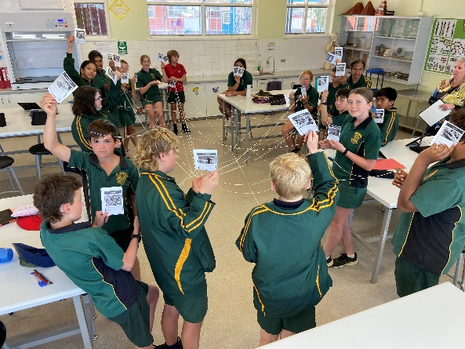

VOCATIONAL EDUCATION
This course is designed to prepare students for life after Dalwallinu DHS and advise them of their options in Years 11, 12 and beyond. Emphasis is placed on the Western Australian Curriculum Work Studies course focussing on the skills for learning and work, and career and life design.
Emphasis is placed on guiding the students in completing job applications, developing personal qualities, exploring work options and also organising visiting speakers from the senior high schools, agricultural colleges and TAFE, along with employers.
Additional topics include:
• Keys 4 Life Program which enables students to sit for their Learner’s Permit. At 16 they can present their certificate and ‘cash’ it in for their Learner’s Permit.
• Financial literacy
Modules and activities cover:
1. Financial knowledge and understanding.
2. Financial competence.
3. Financial enterprise.
4. Financial responsibilities.
Modules include:
• Earning an income
• Spending and saving
• Consumer decisions
• Consumer protection
• Buying a car
• Managing finances
• Work Experience Placement which will include a one week camp to Perth where students will experience real life situations such as making their own lunches, doing their own washing and finding their own transport while also working a full working week.

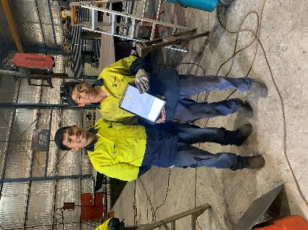
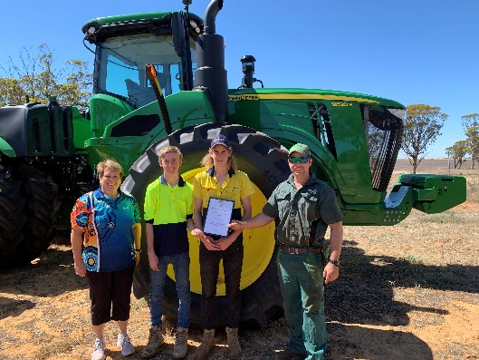
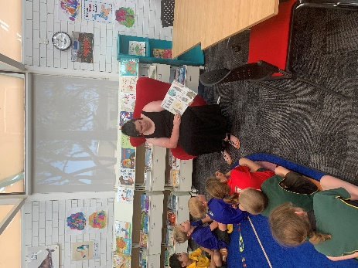

HEALTH AND PHYSICAL EDUCATION LEARNING AREA
Health Education
In today’s society, health is a topic that remains at the forefront of many of our everyday routines and decisions. Health Education at Dalwallinu DHS aims to improve students’ knowledge and skills in a wide range of personal, social and emotional health issues. Values and attitudes are a major component of all health classes.

Health Education operates under the Western Australian Curriculum.

For secondary students Health Education topics covered and consolidated each year. The importance of individual responsibility in choosing healthy practices is stressed. Topics covered throughout the four years of Secondary include:
• Resourceful Adolescent Program.
• Sexuality – personal development, pregnancy, birth, contraception.
• Drug Awareness – peer pressure, tobacco, alcohol, alternatives.
• Mental Health – anxiety, depression, stress management.
• Rethinking Drinking Program – responsible use of alcohol.

Physical Education
General Physical Education is a compulsory subject for Years 7, 8, 9 and 10. Although improving student’s physical skills in a wide range of sports and activities is a major component, the skills of teamwork, cooperation, fair play, and tolerance are also stressed.

All secondary students will participate in a number of different sports. On an annual basis, the students will participate in swimming and athletics.
Note:
A note must be provided before the commencement of Physical Education if:
o A student is unable to participate.
o A student has permission to leave Physical Education directly from the venue (if this is not the school).
Appropriate Physical Education clothing (including hat and sunscreen) should be worn for all lessons.

IN-TERM SWIMMING
We have been able to negotiate a unique position where our secondary students are able to participate in in-term swimming. This further develops their swimming, aquatic care, leadership and self-management skills.
OPTIONAL COURSES – Years 7 to 10
Students choose option courses that run over a semester to cover their choice of study. Students must choose at least one option from each area of the following areas: The Arts / Health & Phys.Ed / Information Technology, Home Economics and Design & Technology.

Whether each individual course operates will depend on student demand for that course and available teacher.
Students are asked to make their selections wisely based on what is of interest to them.

SEMESTER 1 OPTIONS INCLUDE: -
THE ARTS
The World’s a Stage
Description: Students will be introduced to drama techniques while working as a team and communicating with each other. How melodramatic are you? In this course you will refine your acting skills, design a set, get costumed up and perform in different styles of dramatic play where being a drama queen is okay!
Get your Art on!
Description: This art course focuses on you working in the way an artist might work, developing your drawing skills, creative thinking and self-expression through art making. You will be introduced to established artists and use their practice to inspire you to create your own artworks. You will have the opportunity to work within a variety of mediums over the semester. You might create a painting, a sculpture or a print or extend even further into designing a wearable art pieces, use recyclable materials or participate in a community arts project.
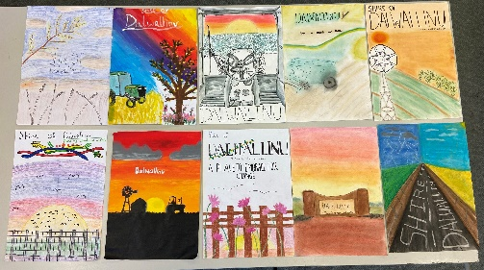
HEALTH & PHYSICAL EDUCATION
Emergency Services
Description: Young people can begin their association with the WA Emergency services where they will participate in interesting and challenging training that provides practical life skills, develops leadership, teamwork and initiative talents, and fosters community responsibility and service. Students will get basic training in First-aid, fire safety, rescue techniques, navigation, bushcraft and more.
Out and About – Outdoor Ed
Description: In this subject students will have the opportunity to learn a range of skills and knowledge which can be utilised in the outdoor environment, including key skills to demonstrate self-preservation, recognising an emergency, determining the priorities of a rescue and emergency care. A camp is a compulsory requirement of the Course and forms part of the assessment process.
AFL Basic Umpiring Course
Description: This unit is the first formal step to becoming an accredited AFL umpire. The course has been designed to cover 7 modules, all of which include some theory and some physical activity.
The seven modules included in the course are:
- Introduction to umpiring
- Positioning
- Decision making
- Communication
- Boundary umpiring
- Goal umpiring
- Fitness & nutrition
On successful completion of this course, student will be eligible to have their skills and knowledge certified by a regional officer. Should they then attain this certification, student will earn Level 1 Umpire status and can umpire local, junior competitions.
TECHNOLOGIES - Design
Building & Construction - Wood
Description: Woodwork focuses on making students aware of the materials and processes available in the woodwork area. Giving students a broad range of skills ready for further education. Machine safety is highlighted with the introduction of the woodturning lathe, scroll saws and other wood machinery. Projects may include a major model or smaller models for students to keep.
Building & Construction - Projects
Description: Woodwork focuses on making students aware of the materials and processes available in the woodwork area. Giving students a broad range of skills ready for further education. Machine safety is highlighted with the introduction of the woodturning lathe, scroll saws and other wood machinery. Projects will be identified projects in and around the school or smaller projects for special occasions to sell. Eg cheeseboards, bookcases in classrooms etc.

TECHNOLOGIES – Home Economics
Food and Lifestyle
Description: This subject is designed to meet the needs of teenagers. A wide range of meals and snacks suitable for teenagers are focussed upon. Foods will be evaluated as to their suitability for the teenage lifestyle and students will be encouraged to make wise decisions in relation to their eating habits. A range of food preparation skills will be taught and students will be encouraged to be confident in preparing food for a wide range of occasions. Various products on the market are evaluated as to their appropriateness for certain groups of people. Students investigate and evaluate the influence of technology in food preparation and food products.
Social Aspects of Food
Description: This course will explore food as a social activity. It will include hospitality, food as gifts (e.g. jams, preserves & biscuits), food for special occasions, food presentation and menu design. Practical sessions will utilise knowledge gained and some gourmet foods will be prepared.
Community Garden
Description: This elective will examine the different methods of gardening and will involve a number of skills such as researching, mapping, budgeting and report writing. Students will also be involved in the planting, reticulation, fertilising and general upkeep of the community garden.
TECHNOLOGIES – Digital
Each Friday afternoon, Secondary students will participate in a variety of Digital Technologies classes which will be spread across the year giving the opportunity for every student to experience each aspect of the Digital Technologies Curriculum.

