DALWALLINU
DISTRICT HIGH SCHOOL

Pre-primary Parent Handbook

Pre-primary 2023

Dear Parents/Guardians,
Welcome to Dalwallinu District High School Pre-primary. The main purpose of Pre-primary is to provide a stimulating play-based environment, in which all children can learn through their own experiences. These experiences will help students obtain the skills necessary for primary school and are carefully programmed based on the children's developmental level and Western Australian Curriculum.

The aims of Pre-primary include:

- Developing a positive attitude to learning.
- Building independence and social skills.
- Encouraging the establishment of good work habits including concentration and perseverance.
- Developing acceptance and understanding of rules and limits.
- Developing basic skills and concepts as a basis for future learning.

Emma Jolly and Kirsten Strickland
Pre-primary Teachers

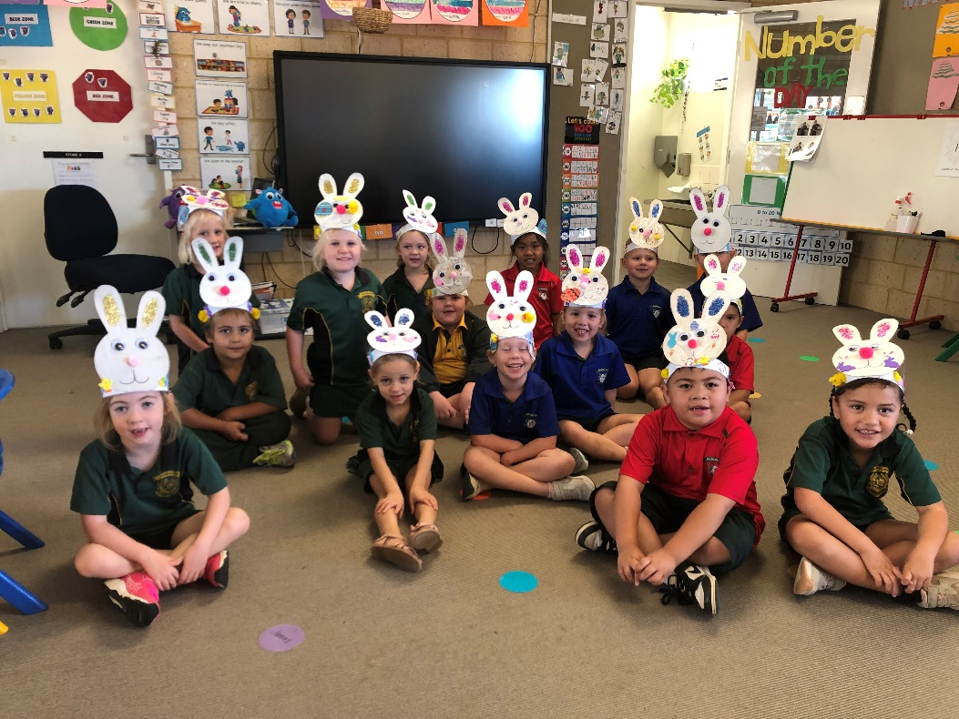

SCHOOL CONTACT DETAILS
For all enquiries, please contact the School Reception. The School Reception at is open between the hours of 8:00am and 4.00pm, Monday to Friday during school terms.

T: 6661 1500
E: Dalwallinu.dhs@education.wa.edu.au

Administration Staff:
Principal: Petrina Bean

Deputy Principals: Melissa Harms - Primary
William Stewart - Secondary

Manager Corporate Services: Jenny Sawyer

School Officer: Rachael Lehmann

TIMES AND DATES

SCHOOL HOURS
School Commences: 8:50am
Morning Recess: 11:00am – 11:20am
Lunch: 1:00pm - 1:35pm
School Dismissed: 3:00pm (2.35pm on Wednesdays)

TERM DATES FOR 2023 (for students)
Semester 1 Term 1 Wednesday 1st February – Thursday 6th April
Term 2 Wednesday 26th April – Friday 30th June

Semester 2 Term 3 Monday 17th July – Friday 22nd September
Term 4 Monday 9th October – Thursday 14th December

OFFICE and SCHOOL DEVELOPMENT DAYS 2023 (students do not attend on these days)
Term 1 – Monday 30th January and Tuesday 31st
Term 2 - Monday 24th April, Friday 2nd June
Term 3 - Wednesday 30th August

PUBLIC HOLIDAYS FOR 2023
Labour Day Monday 6th March
Good Friday Friday 7th April
ANZAC Day Tuesday 25th April
WA Day Monday 5th June

List of Requirements

(Names to be clearly marked on all items)

- 1 LARGE Backpack (to accommodate items such as spare clothes, lunch box, drink bottle and artwork), which your child can open and close INDEPENDENT OF AN ADULT.
- 1 hat to be left at Pre-Primary. All children are expected to wear a hat when playing outside all year round.
- 1 water bottle – send full each day.
- 1 LARGE Library Bag
- 1 SMALL Cushion for rest time.
- Crunch and sip, morning tea and lunch to be brought in separate named containers.
- Spare school uniform – Please send a change of clothing with your child in case of an accident. Remember to update changes of season and your child’s growth.

Please send the below items with your child on their first day of school. Naming items is not required, as all items will be shared.

Description | Qty
Display Book Black 20 Pocket, A3 | 1
Twistable Crayons | 1
A4 plastic wallet clear transparent with zipper | 2
Artline 70 permanent marker, black, 1.5mm | 1
Large GluStik | 6
Junior triangular HB Lead Pencil | 10
Junior triangular colour pencils (pack of 10) | 1
Blunt End Scissors, 130mm | 1
Textas (pack of 12) | 1
Black Whiteboard Markers 2mm | 4
Coloured Whiteboard Markers (Pack 4) | 1

OPTIONAL – A rain jacket and gumboots to wear in wet weather to stay dry, during puddle play. These should be clearly named and will stay at school for the duration of the wet weather period.

School Bags

Your child will need a clearly labelled school bag which is large enough to fit a jumper, food containers, their communication folder and any work they may take home. To promote independence, we suggest purchasing a school bag which your child is able to open and close without a struggle.
Attendance

Pre-primary is the first compulsory year of schooling and the students will attend school full-time from Week 1 of Term 1. They will start each day at 8.50am and finish at 3.00pm, with the exception of Wednesday when school finishes at 2.35pm.

Pre-primary children are to be dropped off no earlier than 8.30am. Classroom doors open at approximately 8.30am. Once the classroom doors have been opened the children will need to complete a few tasks. They are to unpack their bags, and complete any sign in activities. It is a requirement that all children are responsible for these tasks and complete them independently. After these tasks are complete all children can do literacy and numeracy table top activities, blocks and puzzles etc. Please feel free to stay and spend time with your child as they enjoy showing you what they can do.

If your child is late getting to school, they must go to the front office to get a late slip. Siblings may drop off or pick up children, however prior written or verbal communication to the teacher is required. Communication is also required if another adult, other than a legal parent or guardian, is to pick up your child.

Parent Teacher Communication

It is essential that there is regular communication between parents and the teacher. This year we are using communication books. It is expected that parents inform us of any events which may impact their child at school, as well as any changes to drop off/pick up arrangements. Likewise, any incidents etc that occur at school will be communicated via the communication book. Please also feel free to contact us via email. When sending an email to Mrs Jolly and Mrs Strickland, please ensure you include both teachers into the email.

Absentee Notes

Parents are required to contact the Pre-primary teachers via the communication book or email when their child is absent, alternatively email / phone the school notifying the reason for the absence. If you need to take your child from school grounds during the day (appointment etc) they must be signed out and back in at the front office. Parents are not to come to the classroom during the school day (with the exception of Parent Help), any pickups/drop off’s during the day will take place through the office. Please note: if your child is absent from school without reasonable cause then an SMS will be sent from administration to your phone.

Illness / Medicine

If your child is unwell, please consider the other children, as well as staff, and realise the best place for him/her is at home with you. In the instance of your child having an infectious disease, (eg—chicken pox, school sores, ringworm or conjunctivitis), please inform the school so that we can notify other parents. Parents are also asked to check their child’s hair regularly for head lice (nits). If your child has head lice, health regulations require you to keep your child at home until they have been treated. It is not the duty of the teacher to check for head lice but if they are found in a child’s hair the parent will be contacted and a note will be sent home. A general note will also be sent to the other parents advising them to check their children. Pillows and hats will also be sent home for washing. If your child is sick or has been involved in an accident at school, we always try to contact you. For parents to be contacted, it is essential that the school has current contact information for parents/guardians and emergency contacts.
If it is necessary for your child to take any medication during school hours, the parent/guardian must complete and sign the appropriate form before staff will administer any medication. Medication should be in original containers with clear instructions for use. Please inform staff of any allergies your child may have.

Bus Children

Bus children generally walk to the classroom with siblings or older students in the morning. In the afternoon, bus children are put on the bus by the class Education Assistant. It is essential that you notify the classroom teacher and the bus driver of any changes to transportation routines, via communication book or email to the teachers.

Newsletters

School newsletters will also be sent home electronically, unless you have requested a hard copy.

Questions & Concerns

If you have any questions or concerns, please come and speak with a staff member at your earliest convenience. We need to work together as a team to achieve the best possible outcomes for your child.

Parent Roster

A parent roster will be organised in the first weeks of the term. This is an important part of your child’s educational program as it allows you to become familiar with Pre-primary and the learning programs we offer. It is also a special time for your child. All parents on roster are asked to visit the front office of the school to sign the visitor’s book before starting roster so administration staff are aware of all visitors to the school. We acknowledge that parents are very busy and are flexible with times, however most parents stay from approximately 8.50am until 11:00 am (recess).

Student Dress

The school dress code is the same as that worn by the children in the primary school, this is a bottle green polo shirt with bottle green shorts/skirt, or a white/bottle green check dress. Uniforms can be purchased through the school canteen and more detailed copies of the uniform policy can be obtained from the office. Please label all clothes clearly with your child’s name. Children need to wear footwear to school every day that they are able to put on and take off themselves. Sneakers and sandals are the most suitable and thongs or heeled shoes are inappropriate for school. A spare set of school uniform should be kept in your child’s bag at all times in case of accidents. Faction shirts are to be worn on the faction carnival days. These shirts can also be worn on the day your child has sport at school. On the day the Pre-primary students have sport, they may wear their faction shirts.
Sun Protection

Our school has a “NO HAT – STAY IN THE SHADE” policy. Children will be required to stay in the shade if they do not have a hat. Their hat will be kept in the classroom for the year and sent home for washing at the end of each term. Please return the hat at the beginning of the next term. Please make sure your child’s name is marked clearly on the hat.

Laundry

It is inevitable that children will get some paint and possibly glue on their clothes. To remove paint and glue, soak the clothes in COLD water, scrub with a stain remover and then wash in the machine. DO NOT spray clothes with pre-soaker spray, as this will make the paint stain.
Food Requirements

Each child is to provide their own healthy crunch and sip, morning tea and lunch in separate containers, labelled with his/her name. All children must also bring a labelled water bottle each day; no juice, cordial or soft drink is to go in water bottles. Please inform the school of any food allergies or special dietary requirements your child may have.

Home Activities

Throughout the year we will send home simple literacy and numeracy activities to help reinforce some of the skills and concepts being covered in class. These activities shouldn’t take too much time and are a great way for you to feel involved in your child’s learning. Further homework details will follow.

Library Sessions

All children have the opportunity to use the library facilities each week. Children will need to bring in a named cloth bag in order to borrow a book. Details regarding “Library Day” will be sent home in Week 1.

Toys

Do not allow your child to bring toys to school. This is to avoid toys getting lost or damaged please.
Money

Children in Pre-primary generally have no reason to bring money to school. Any money which is sent to school (i.e. for Swimming or Book Club) needs to be in an envelope with the correct amount, name and reason on the front. Please note a Book Club catalogue will be sent home monthly and swimming lessons will take place in Term 1.

Birthdays

These are special to each child. Small cupcakes may be brought in to be shared with other students. Please check with staff prior to the date to ensure dietary and allergy conditions of all students are catered for.

Assemblies

Whole school assemblies are held twice a term with classes from K-10 taking turns to present a small item. If your child is being presented with an award, you will be notified.

Preparing your Child for Pre-primary

- Talk about Pre-primary as fun, something to look forward to each day.

- Send your child to Pre-primary regularly and promptly.

- Have a look at the work your child brings home and show interest in what they have made by asking them questions about how they have made it.

- Praise all efforts.

- Complete the home sound/reading program as instructed.

- Read a special story to your child as often as possible. Talk about the story and ask questions. Encourage your child to retell stories in their own words.

- Provide materials at home – pencils, crayons, paper, colouring in books, scissors, glue sticks, so your child can draw, write, cut, glue, etc.

- Encourage your child to practice writing their name – a capital letter is used to start a name and it is completed using lower case letters.

- Count to 20 and beyond! Count forwards and backwards.

- Talk often – sing rhymes and songs together.

- Place your name on the Parent Roster as often as possible each term.

- Spend some time each morning in the Pre-primary when you drop your child off to start the day.

- Attend the special days (i.e. Easter Party) at the Pre-primary so that your child can have lots of fun with you in their daily learning environment.

Correct Pencil Grip

It is important that we work together to develop a correct pencil grip for your child. Please encourage your child to hold their pencil correctly when they are working at home. The older they get the harder it is to change a bad habit!

